

**Data Science Portfolio**

Module Leader: **Khadija Katanani**

Word count**: 2129**

Student name: **Natalia Bochnia**

Student number: **10181827**

Table of Contents

Table of figures 3

Introduction 4

Methods 4

Analysis 4

Cleaning the data using Python 4

Uploading and displaying data 4

Data examination 6

Dropping columns 6

Checking for null and unique values 7

Creating new column 8

Missing values 9

Correlation 11

Outliers 11

Random Forest Regressor 12

Metrics calculation 13

Simple Imputer 14

KNNImputer 15

Median Imputation 17

RegEx Module 18

Outliers replacement 18

Analysing the data 20

Question frequency distribution 20

Older adults falling with injuries- by gender and race 22

Older adults with lifetime diagnosis of depression – by gender, age and race 24

Depression diagnosis trends and predictions - by gender 28

Data extraction 30

Tableau analysis 30

Trends in vegetable consumption among older adults 30

Geographical analysis of binge drinking – by race 31

Sleep analysis – by race 34

Evaluation 35

Limitations 35

Conclusion 36

Bibliography 36

# Table of figures

Figure 1 4

Figure 2 4

Figure 3 5

Figure 4 5

Figure 5 6

Figure 6 6

Figure 7 7

Figure 8 7

Figure 9 8

Figure 10 9

Figure 11 10

Figure 12 11

Figure 13 12

Figure 14 13

Figure 15 14

Figure 16 15

Figure 17 16

Figure 18 16

Figure 19 17

Figure 20 17

Figure 21 18

Figure 22 19

Figure 23 20

Figure 24 21

Figure 25 21

Figure 26 22

Figure 27 22

Figure 28 23

Figure 29 23

Figure 30 24

Figure 31 24

Figure 32 25

Figure 33 25

Figure 34 26

Figure 35 26

Figure 36 27

Figure 37 28

Figure 38 28

Figure 39 29

Figure 40 29

Figure 41 30

Figure 42 31

Figure 43 31

Figure 44 32

Figure 45 32

Figure 46 33

Figure 47 34

Figure 48 34

# Introduction

The healthcare sector is witnessing a data-driven revolution, facilitated by the availability of vast medical datasets. With data sourced from the Centers for Disease Control and Prevention (CDC), this report explores the potential of healthcare data analysis to uncover insights crucial for informed decision-making.

Amidst the proliferation of electronic health records and wearable devices, the analysis of medical data holds promises in improving clinical outcomes and public health. However, challenges such as data quality issues and the need for skilled analysts persist.

This report aims to leverage data analytics techniques to explore, clean, and visualize healthcare datasets. the objective is to contribute to the understanding of key healthcare indicators and inform evidence-based strategies for healthcare management and policymaking.

# Methods

Dataset:

[Link to access the original dataset](https://catalog.data.gov/dataset/alzheimers-disease-and-healthy-aging-data)

[Link to access my cleaned data](https://www.dropbox.com/scl/fi/11pdv8vgvozzhpvkobn61/Alzheimer_s_Disease_and_Healthy_Aging_Data_modified.csv?rlkey=bxpyjm8s03m1pbaknoevjlzr2&dl=0)

The dataset utilized in this analysis was sourced from the Centers for Disease Control and Prevention (CDC), a leading public health institute in the United States. The dataset contains comprehensive information on various health indicators, demographic factors, and geographic attributes.

The decision to choose this dataset was informed by its relevance to public health research and its potential to uncover valuable insights into healthcare trends and patterns. Specifically, the dataset provides granular details on health behaviours, chronic conditions, and risk factors among different population groups, making it ideal for exploring the dynamics of health outcomes.

The dataset provides a rich source of information for exploring health disparities, identifying risk factors, and informing public health interventions. By leveraging this dataset, this analysis aims to contribute to the understanding of key health issues and facilitate evidence-based decision-making in healthcare.

# Analysis

## Cleaning the data using Python

### Uploading and displaying data

First, I upload all the necessary libraries, upload the data set to Google Collab and display sample data. Sample() function instead of head() provides a more comprehensive representation of the dataset's structure and characteristics. While head() typically displays the first few rows of the dataset, sample() randomly selects rows from the dataset, offering a more diverse snapshot of the data distribution

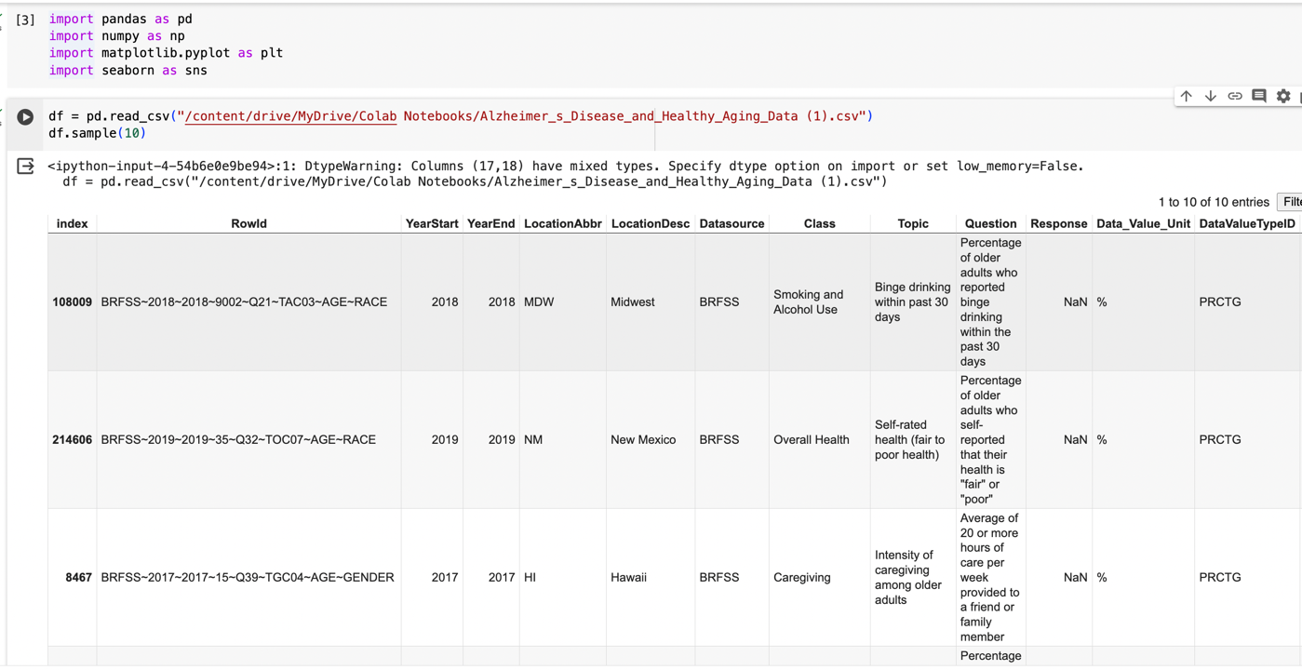

Figure 1

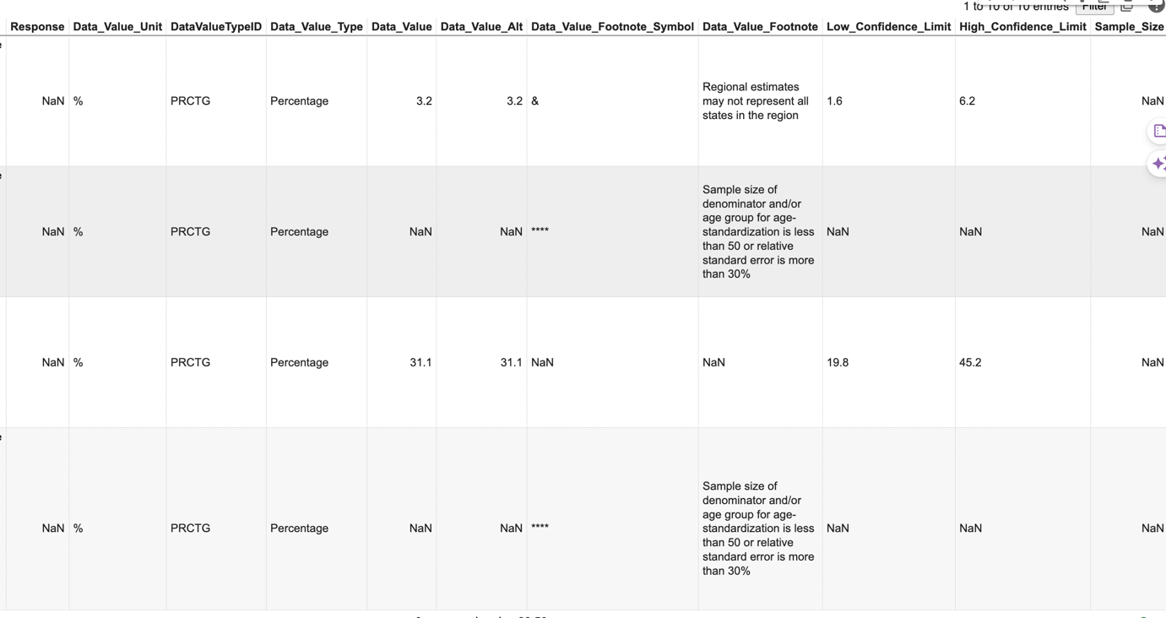

Figure 2

### Data examination

I examine shape() and count() to evaluate the dataset's size and completeness

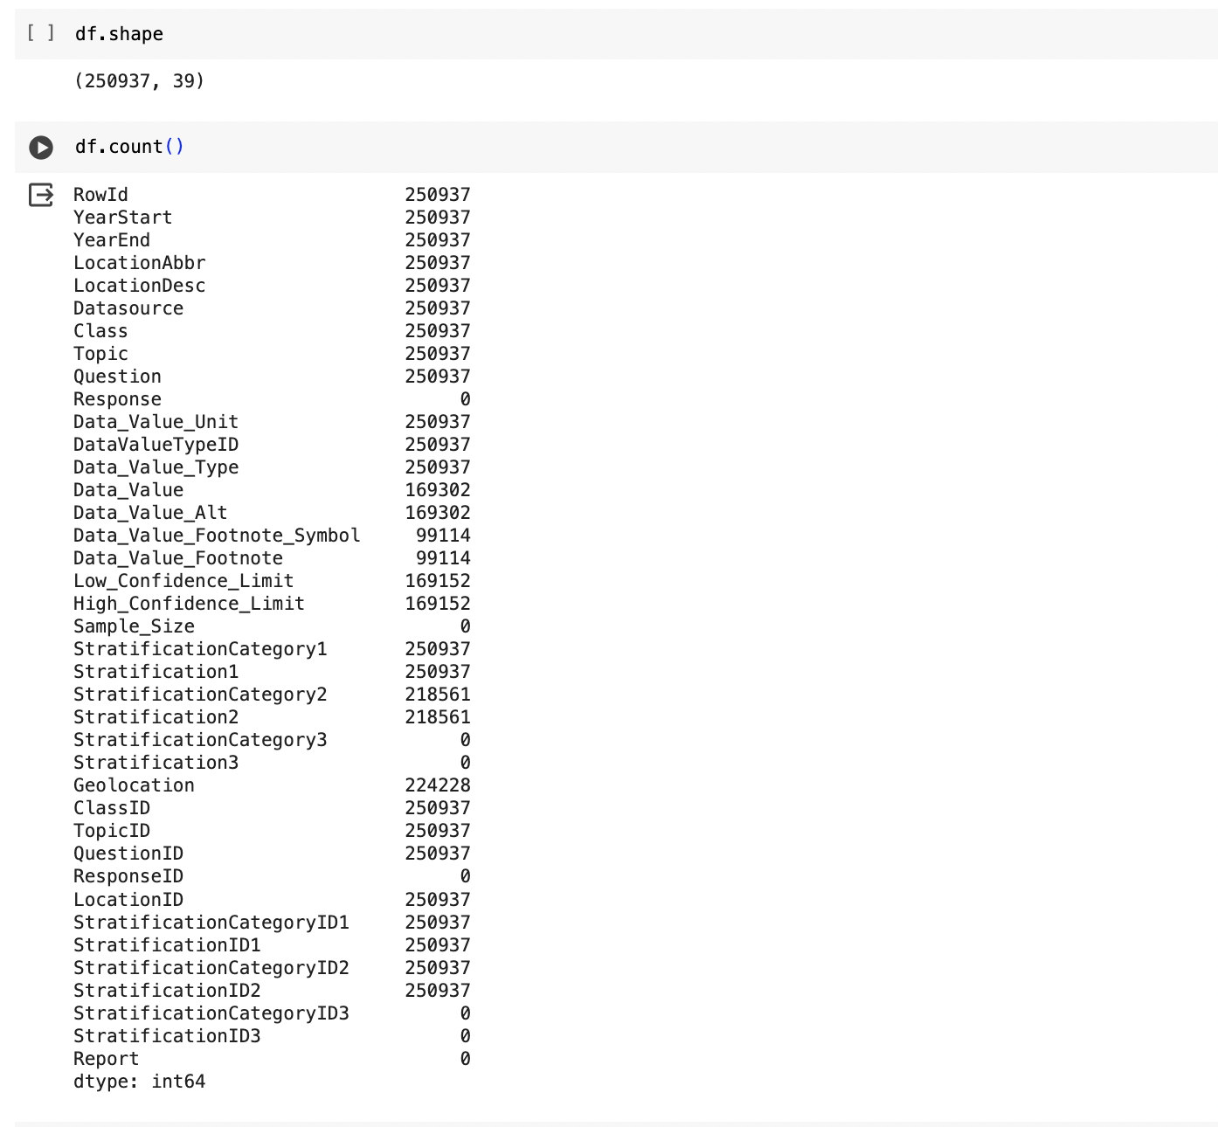

Figure 3

### Dropping columns

I identify and drop columns that contain no values at all.

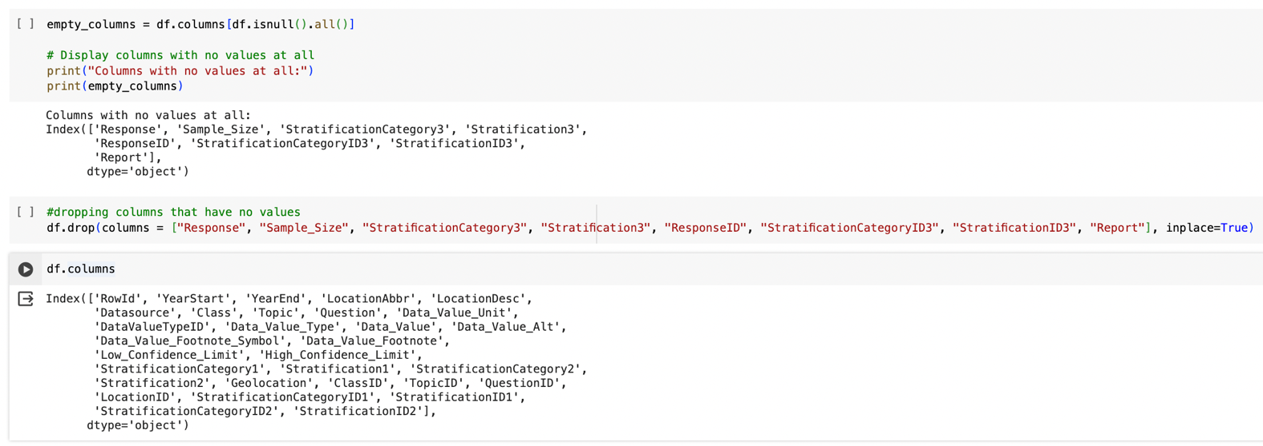

Figure 4

### Checking for null and unique values

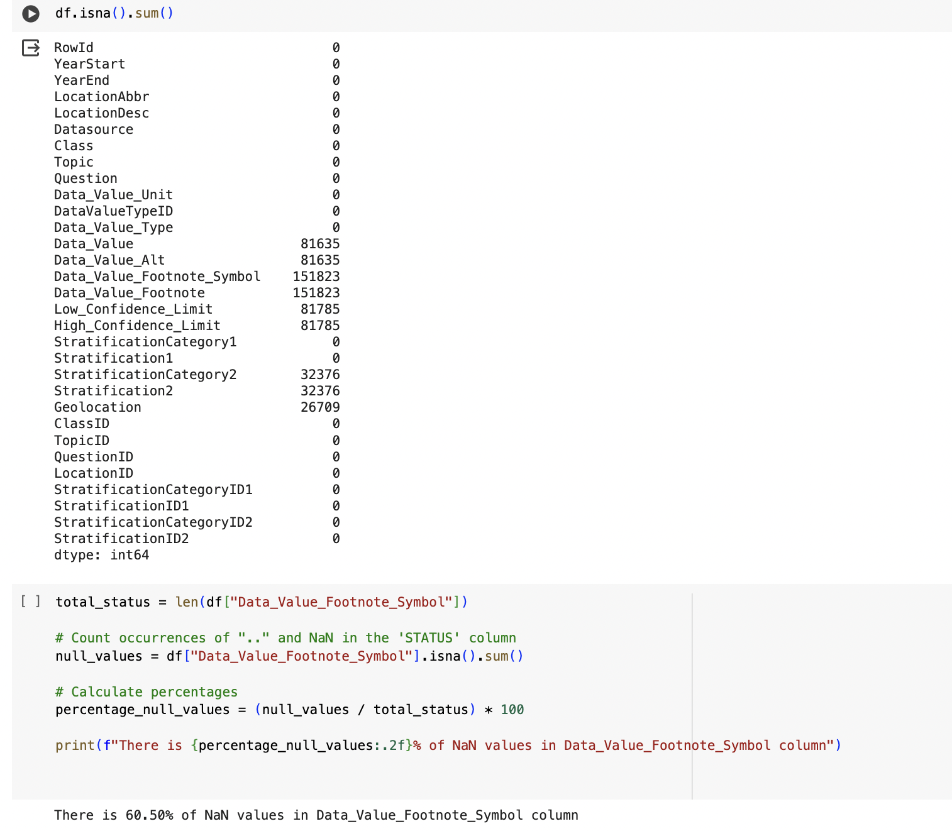

Figure 5

I check for the unique values and drop explanatory columns that I don’t need and keep the ID’s columns.

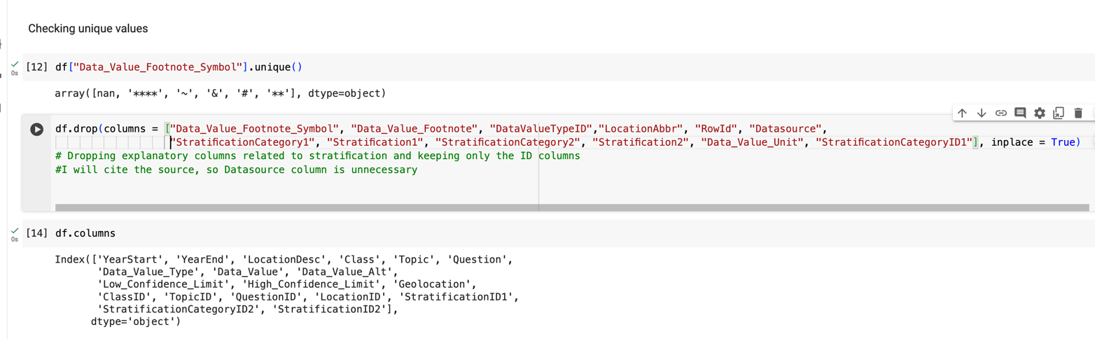

Figure 6

Data Value and Data Value Alt are the same or extremely similar, that's why I decided to drop one of these columns.

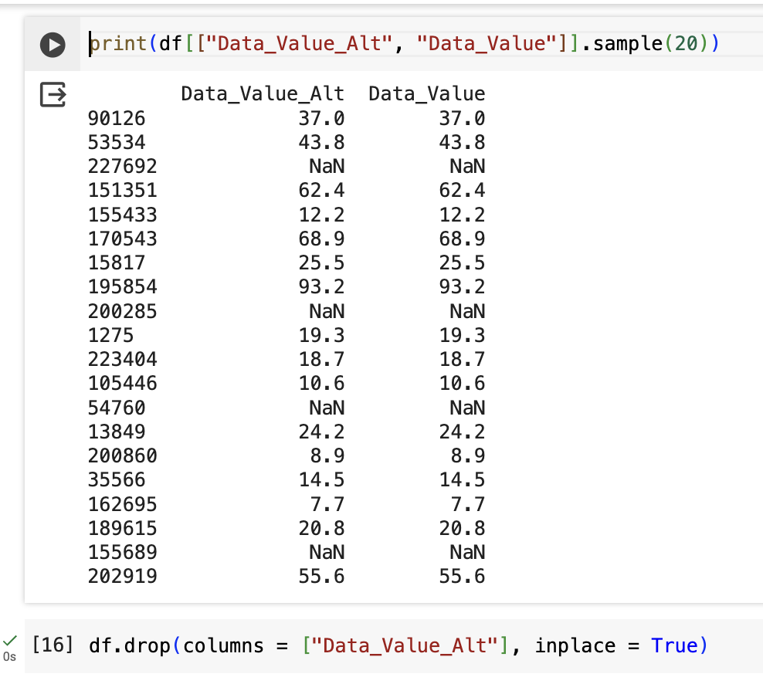

Figure 7

### Creating new column

I create the copy of my data; I check if there are any columns that are duplicated. I create new column named Year, as Year Start and Year End have over 95% of the same data.

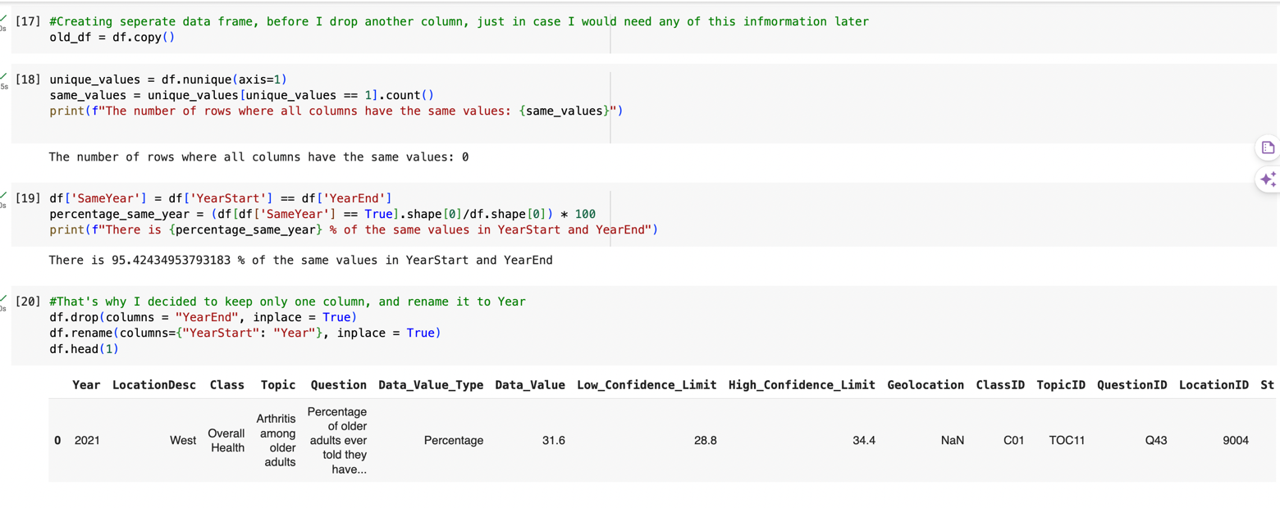

Figure 8

### Missing values

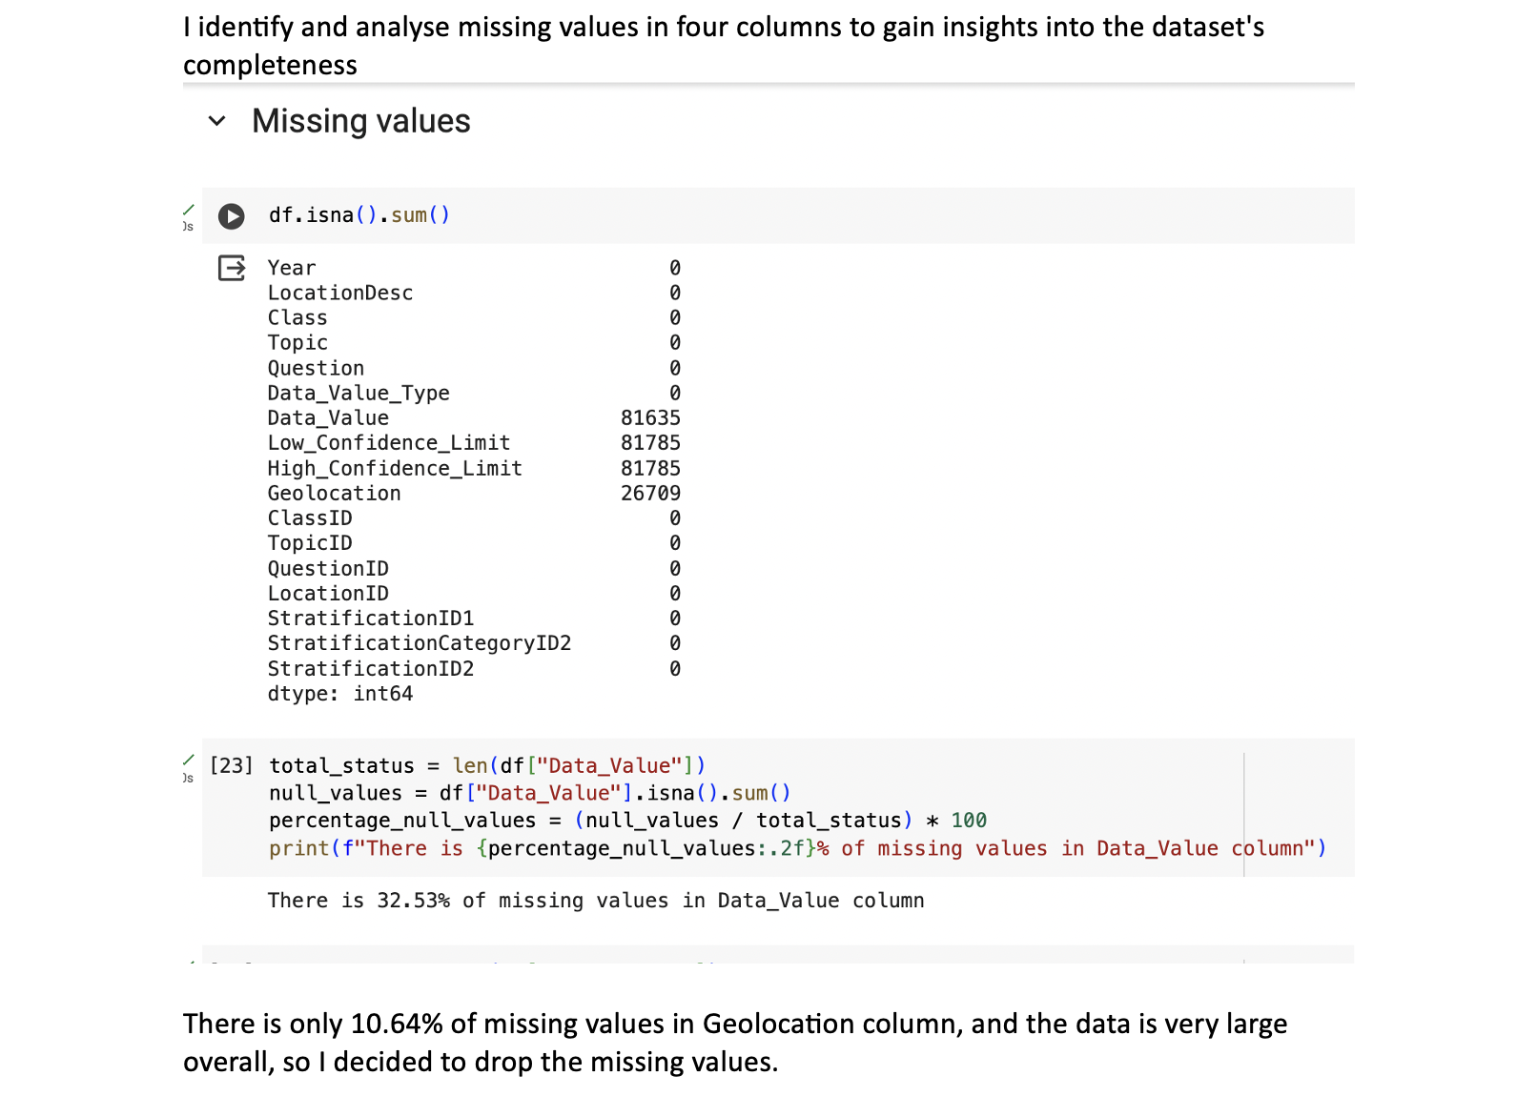

Figure 9

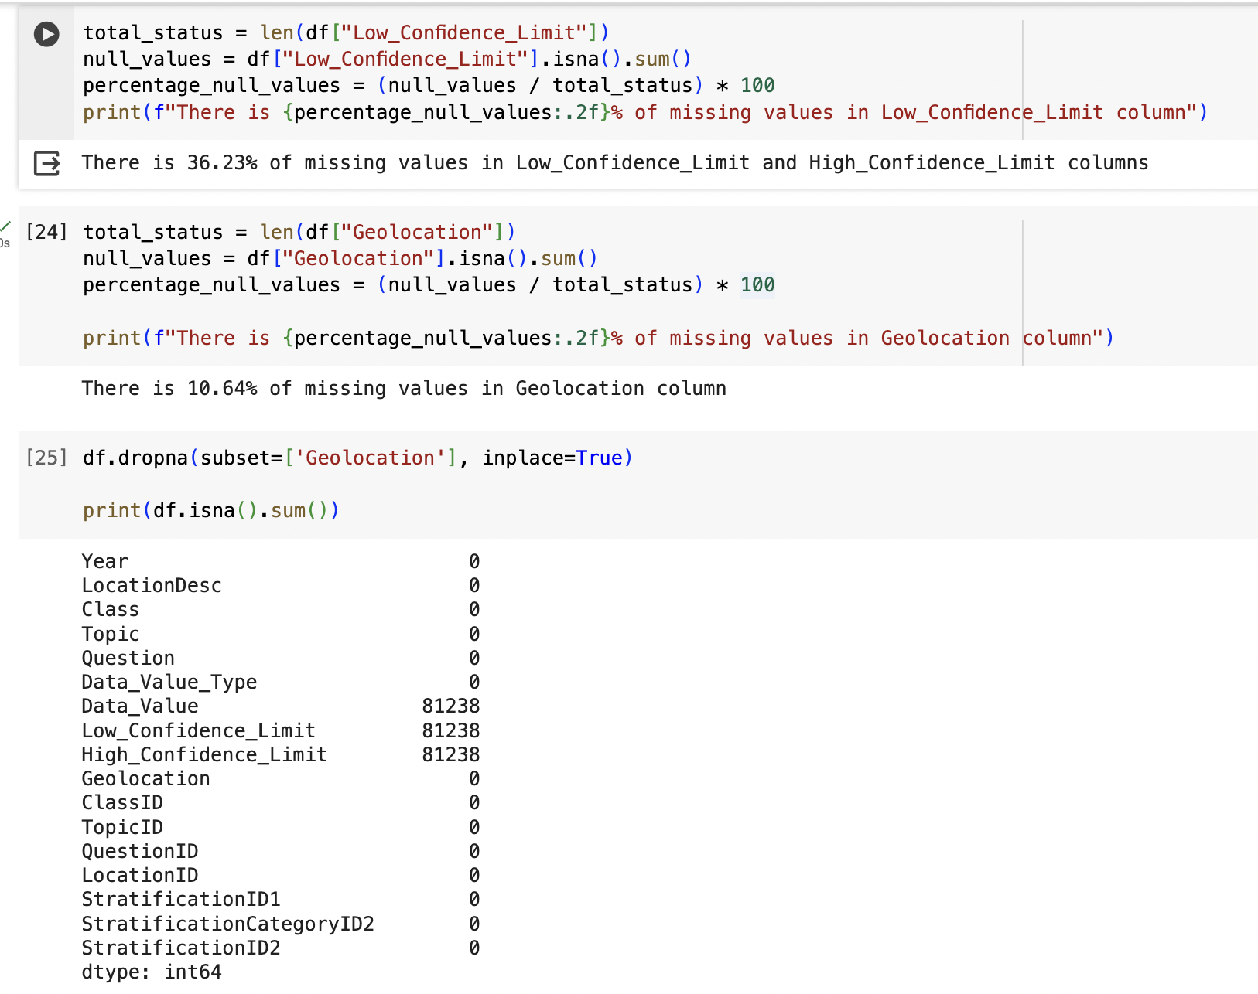

Figure 10

### Correlation

Next, I check for correlation with a heatmap, but there is no significant correlation between my numerical data.

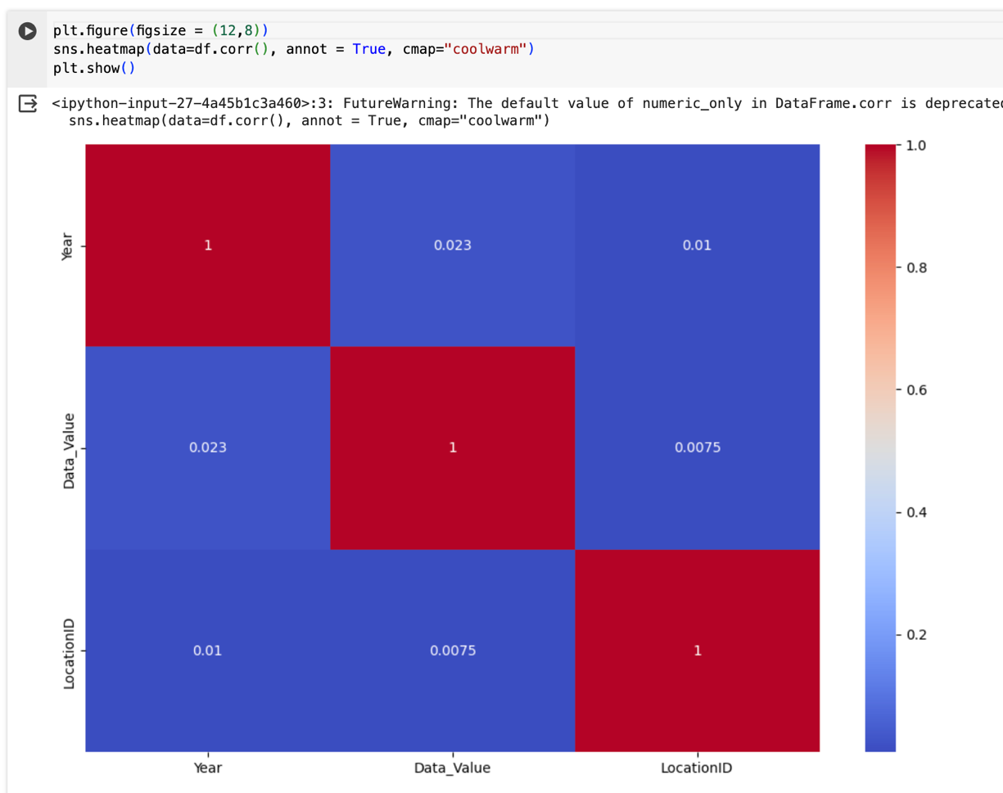

Figure 11

### Outliers

I check for any outliers. To do so I use zscore.

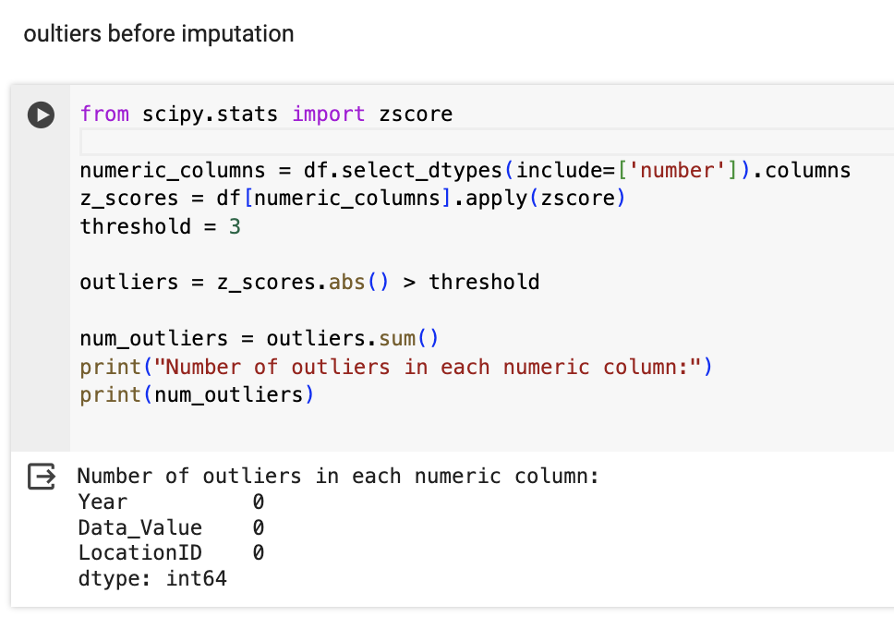

Figure 12

### Random Forest Regressor

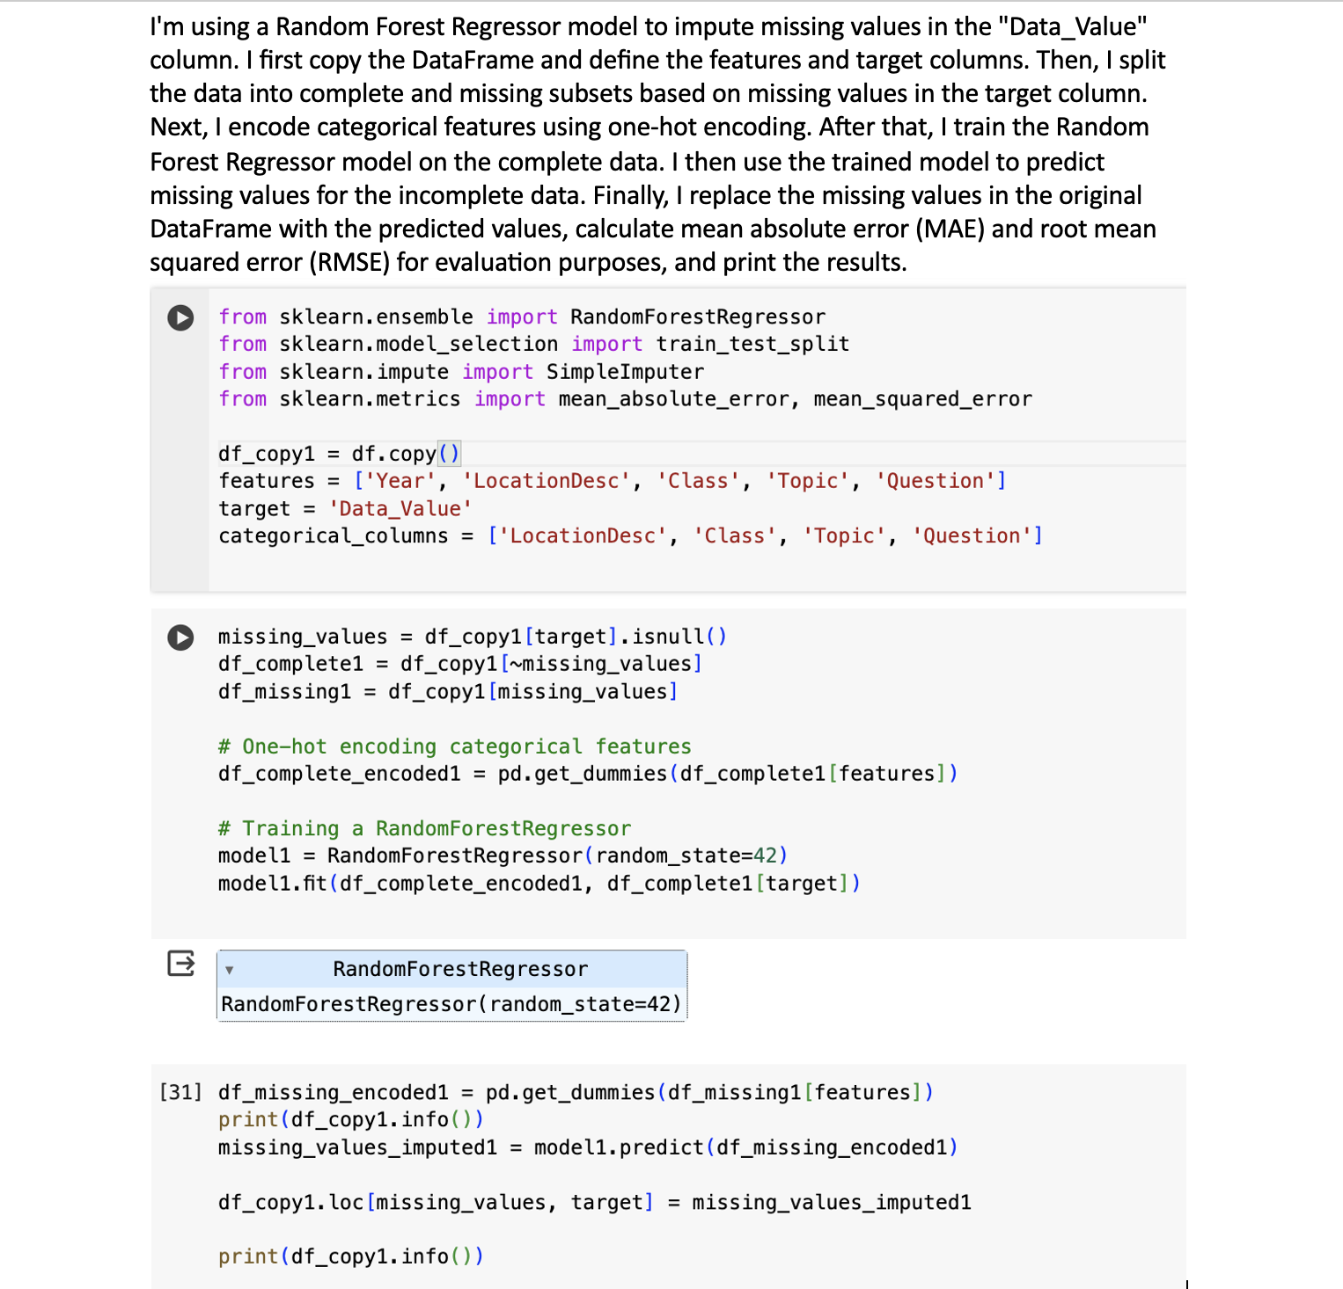

Figure 13

### Metrics calculation

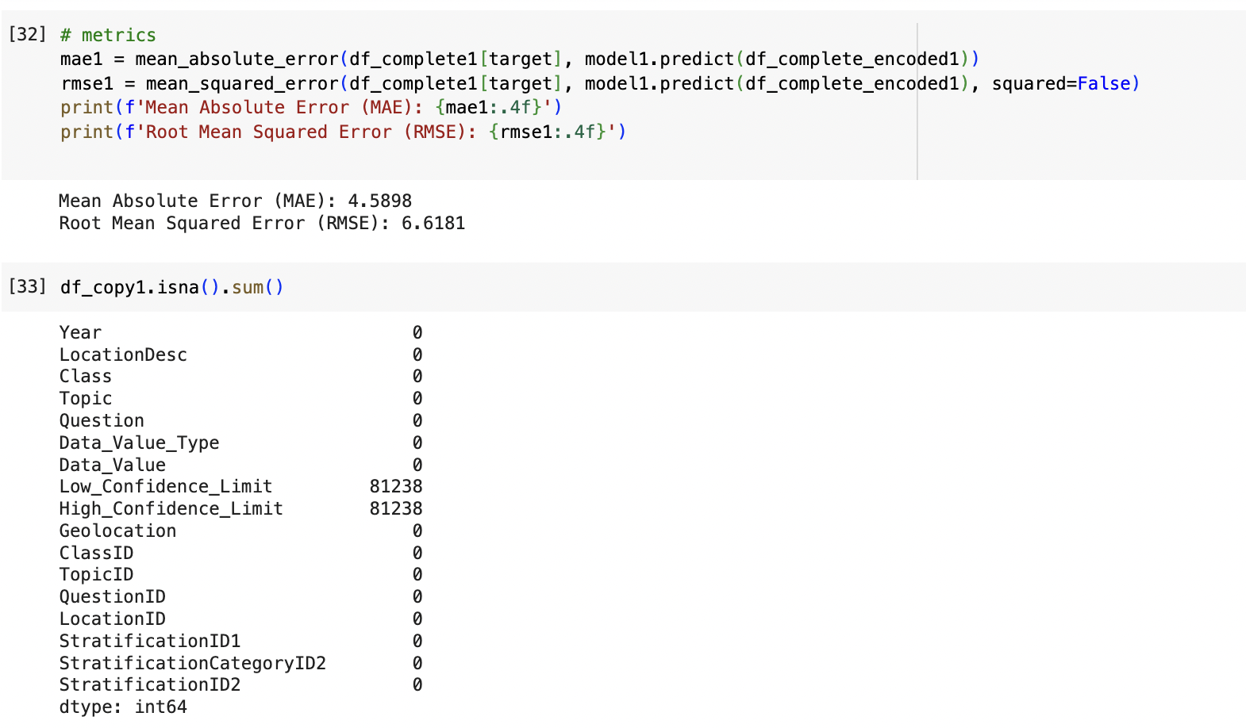

Figure 14

### Simple Imputer

Using SimpleImputer, I fill missing "Data_Value" entries with the median value. Then, I assess the accuracy of imputation with MAE and RMSE metrics.

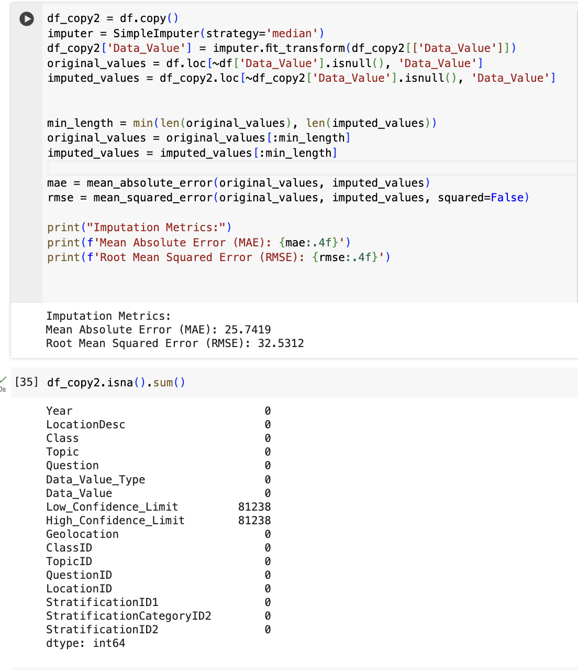

Figure 15

### KNNImputer

I use the KNNImputer from scikit-learn, which imputes missing values by considering the k nearest neighbors of each sample. This method estimates missing values based on the values of other features in the dataset. After imputation, I check for any remaining missing values. Finally, I compute the MAE and RMSE metrics.

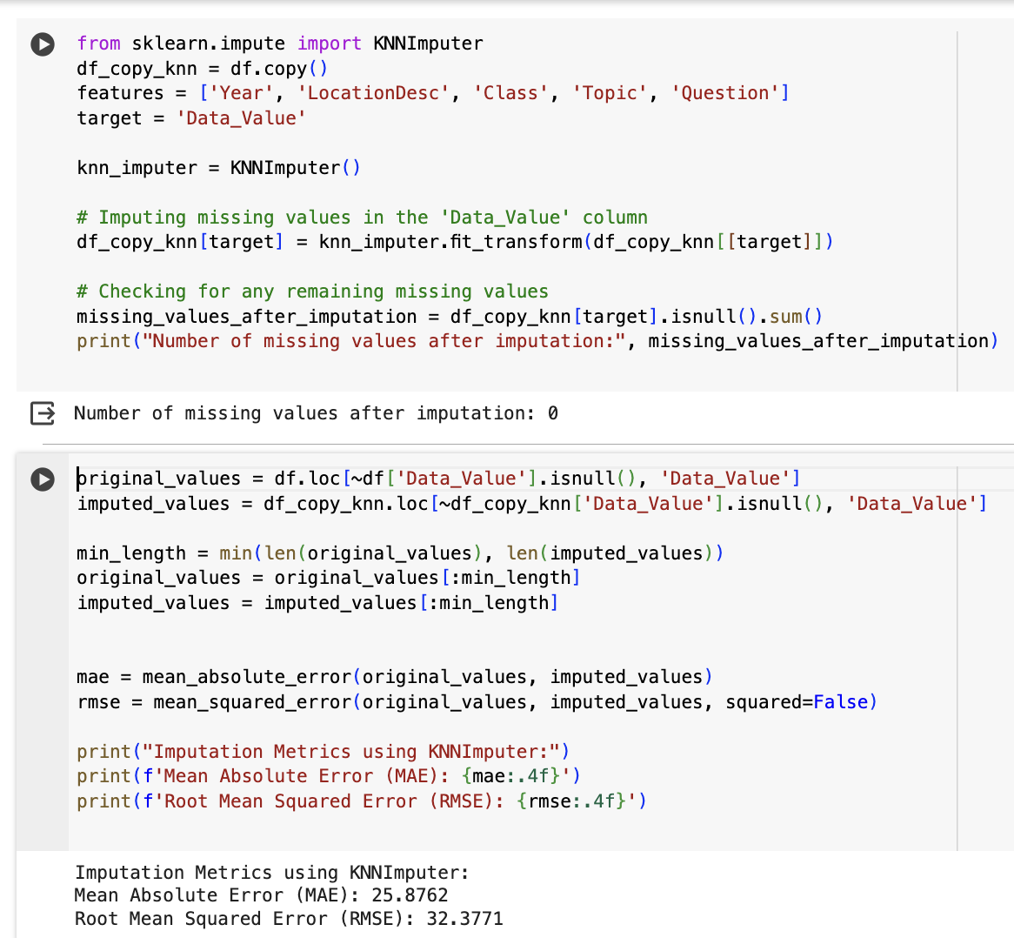

Figure 16

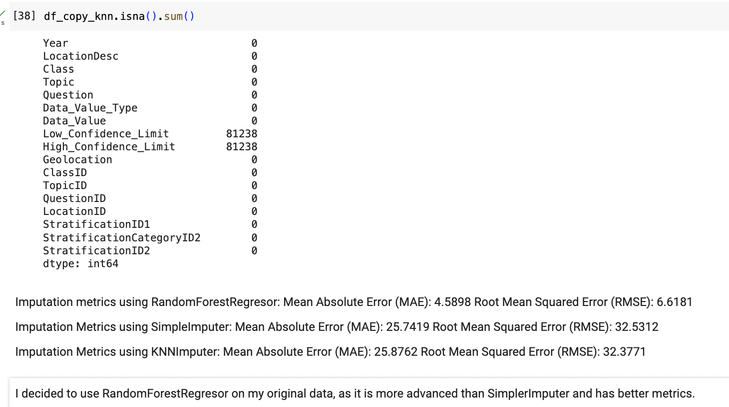

Figure 17

I'm comparing the original null values with their imputed counterparts to assess the effectiveness of the imputation process.

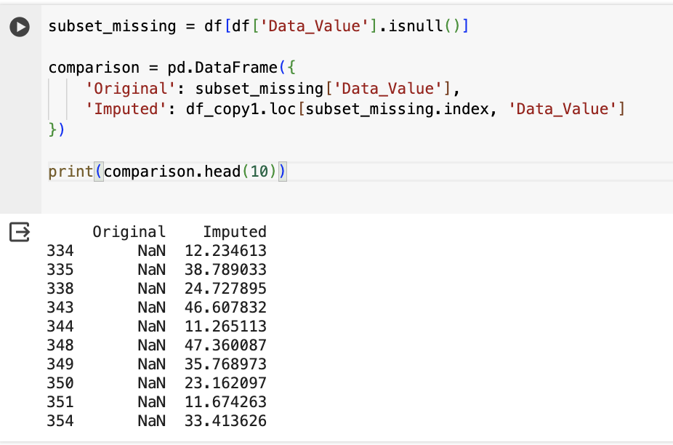

Figure 18

### Median Imputation

I'm performing imputation (first on the copy of my data) on missing values in the 'Low_Confidence_Limit' and 'High_Confidence_Limit' columns based on the median values grouped by 'LocationDesc'.

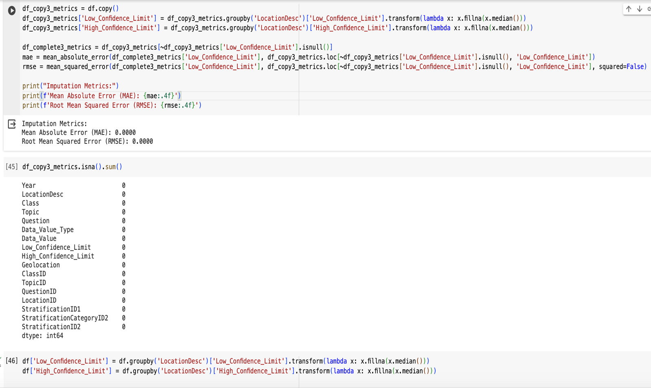

Figure 19

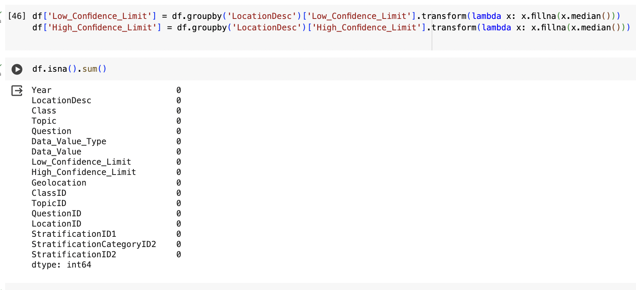

Figure 20

### RegEx Module

I'm using a regular expression pattern (ptn) to identify values in the 'Data_Value' and Low_Confidence_Limit columns that have more than three decimal points. I then filter the DataFrame to extract these values and check if there are any such values present. Then I round numerical columns to 2 decimal places, for data to look clearer and be more consistent.

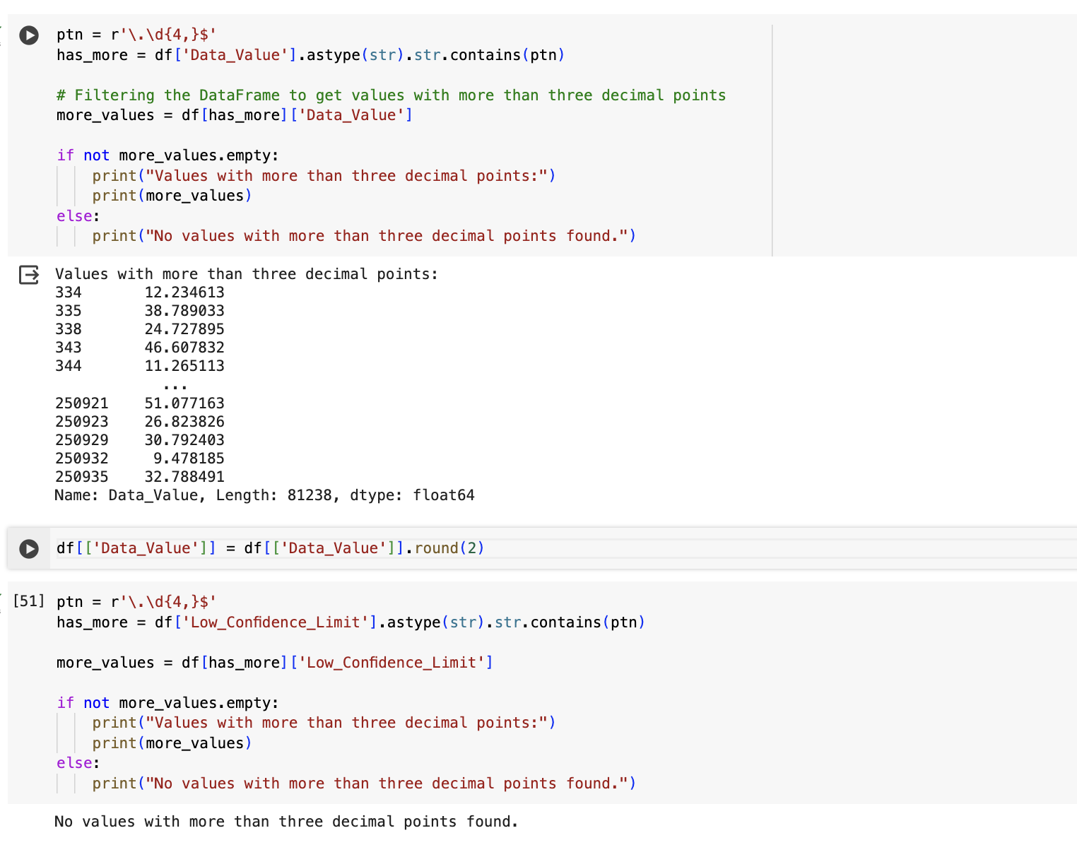

Figure 21

### Outliers replacement

I check for any outliers after imputing all the missing values. I found some in Low_Confidence_Limit column so I replace any values that exceed the 99th percentile with the value of the 99th percentile itself.

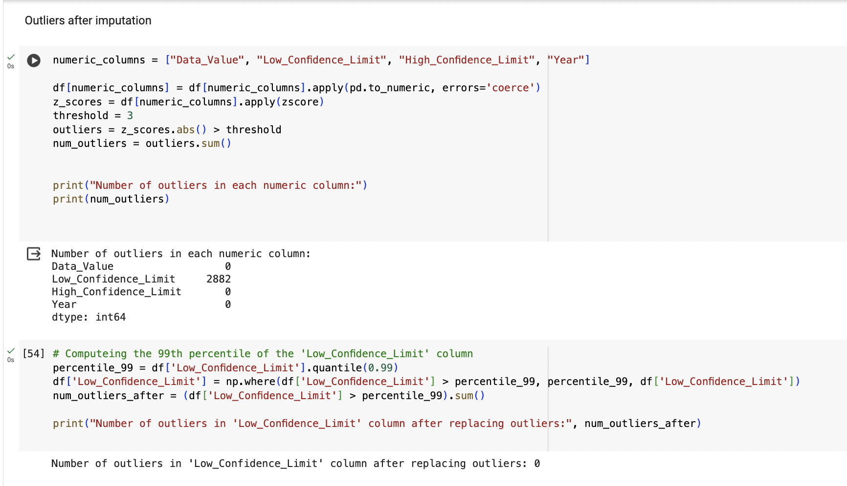

Figure 22

## Analysing the data

### Question frequency distribution

I check which questions appears the most often in the data.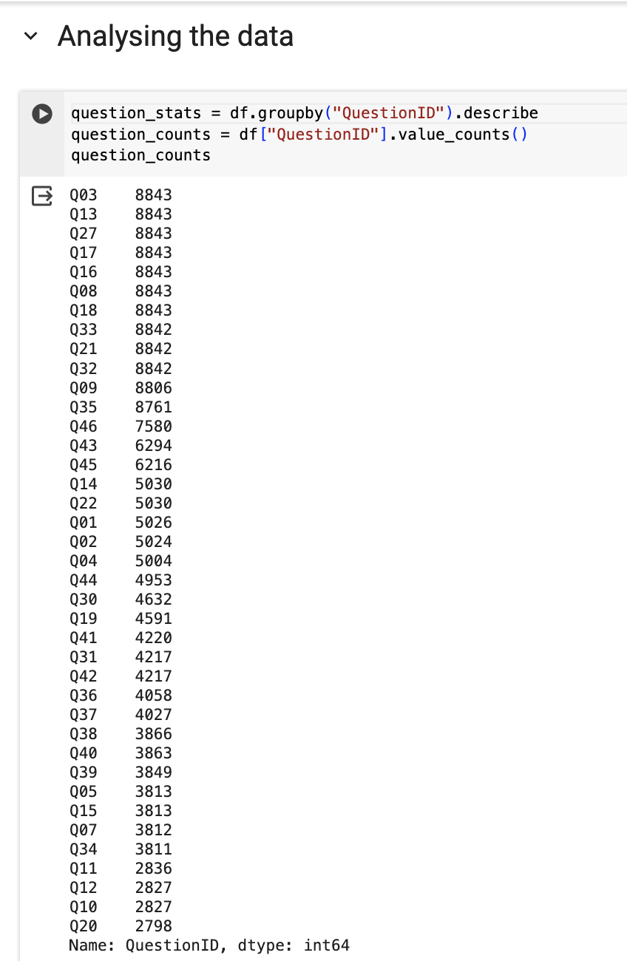

Figure 23

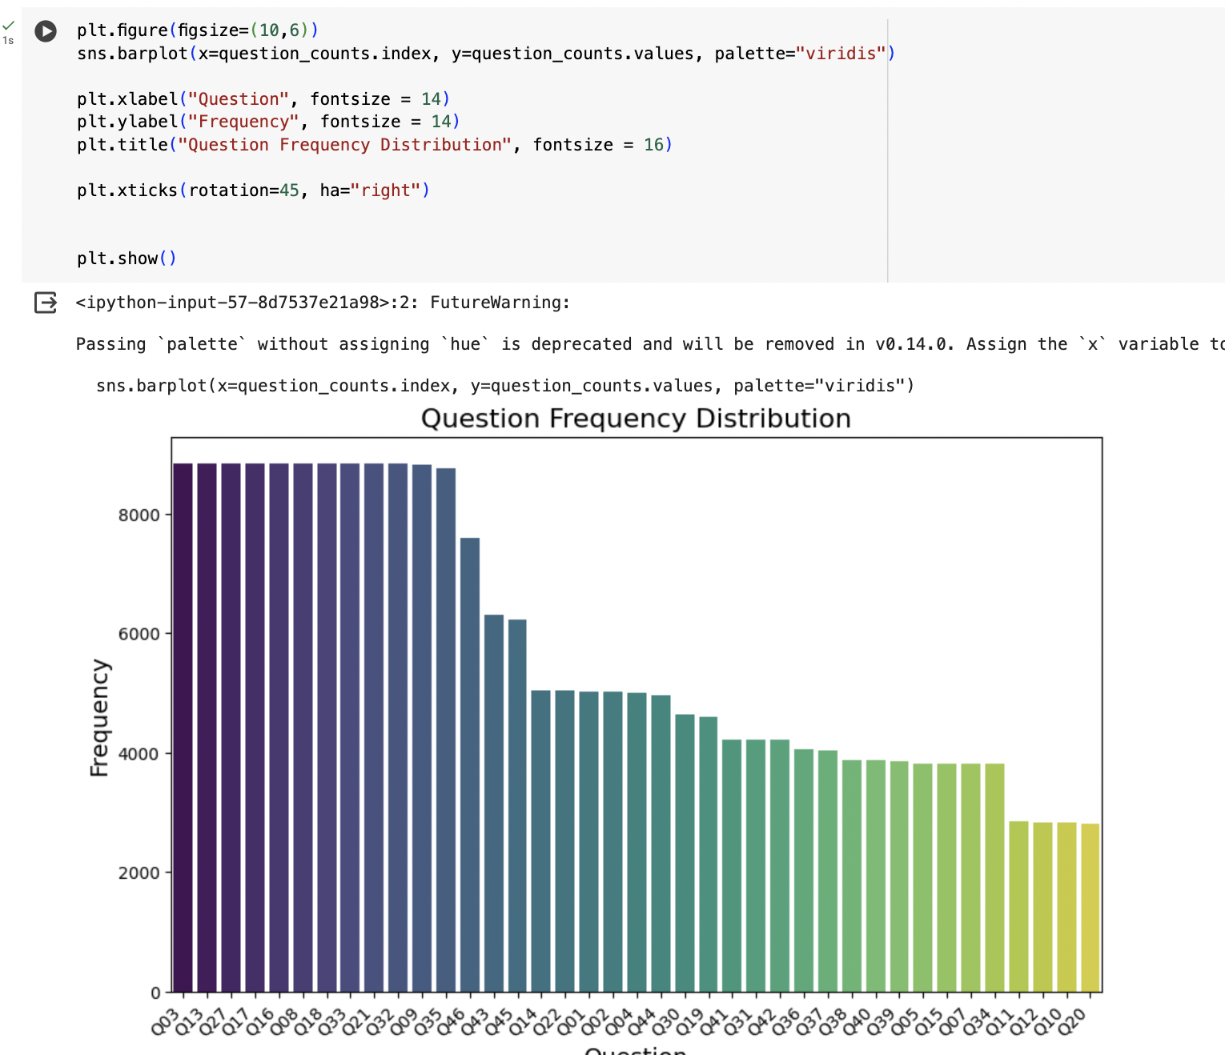

Figure 24

I try to understand the question and see how it is related to the other data.

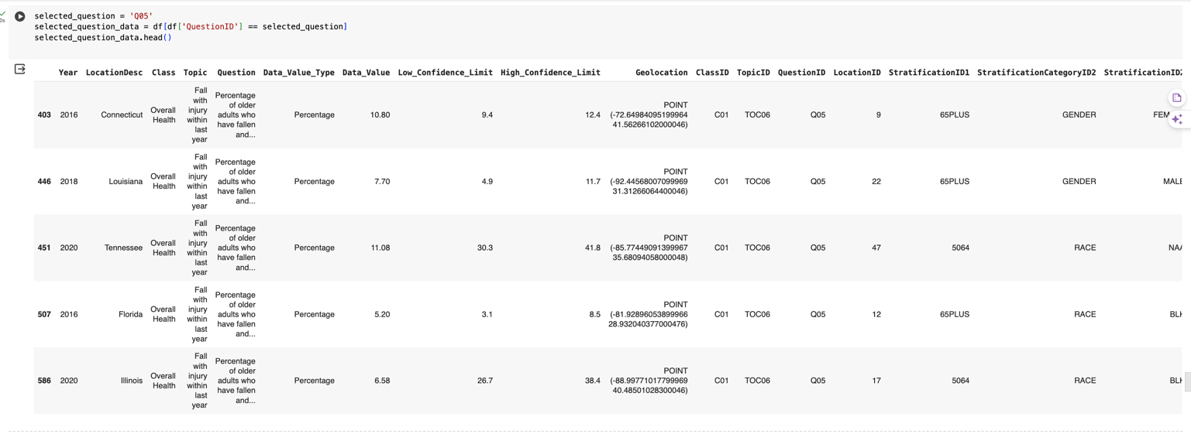

Figure 25

I'm analysing fall-related data by filtering rows. The purpose is to compute and compare the mean 'Data_Value' for different gender categories ('StratificationID2').

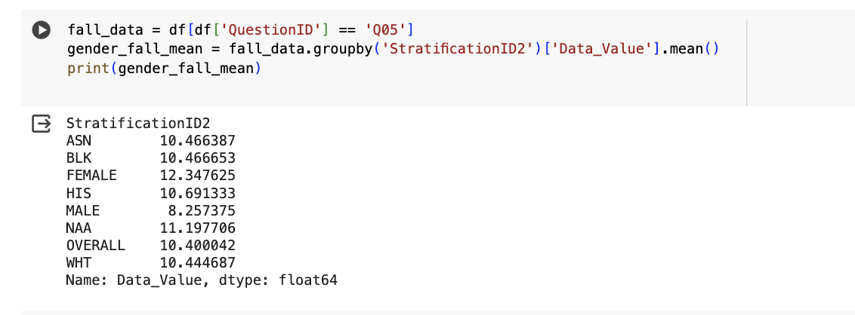

Figure 26

### Older adults falling with injuries- by gender and race

I'm creating bar plots to visualize the percentage of older adults falling with injury categorized by gender and race.

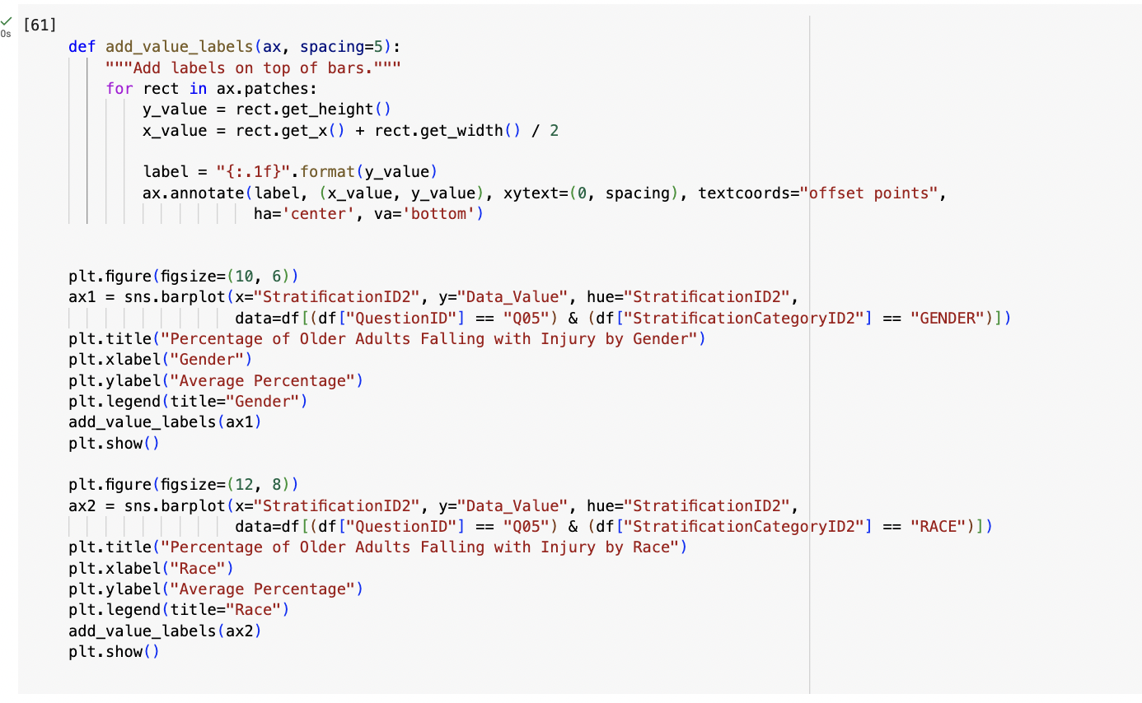

Figure 27

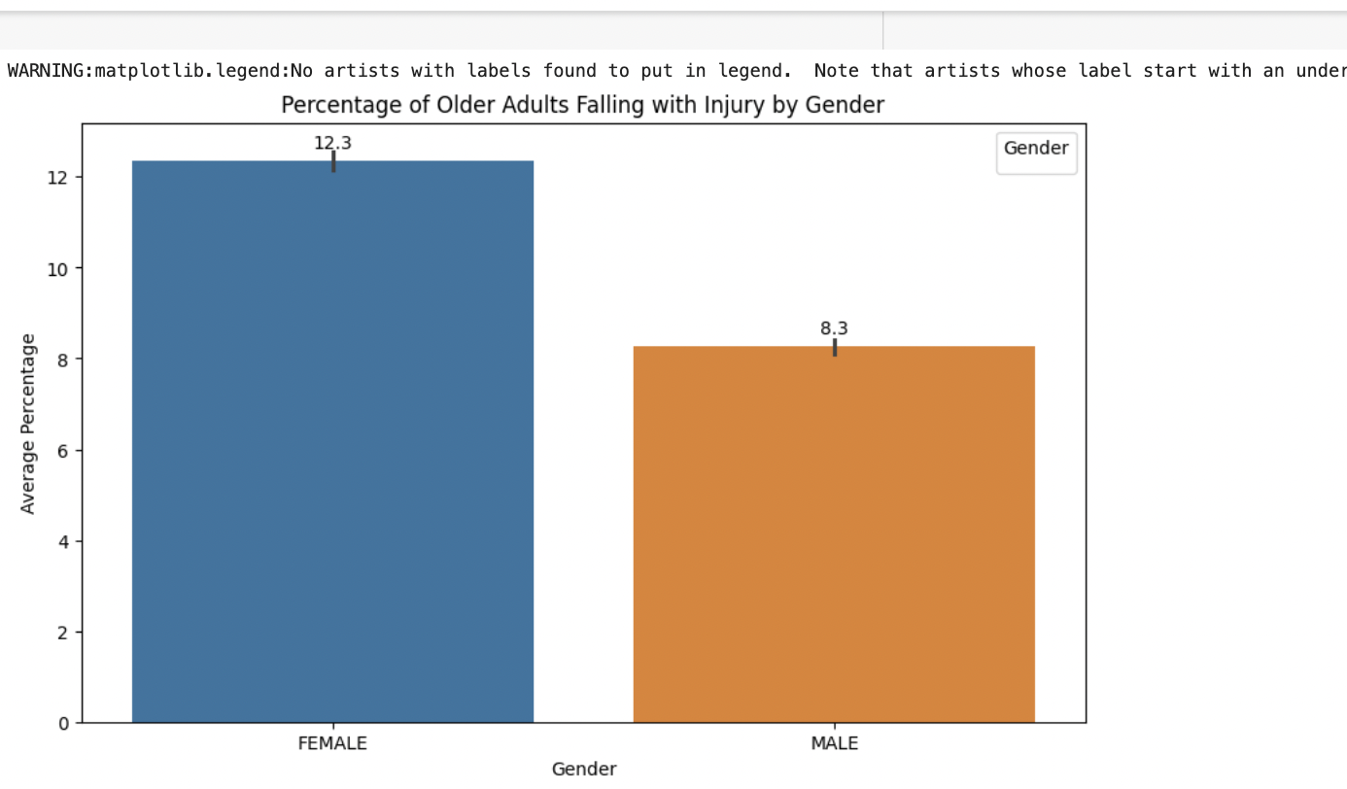

Figure 28

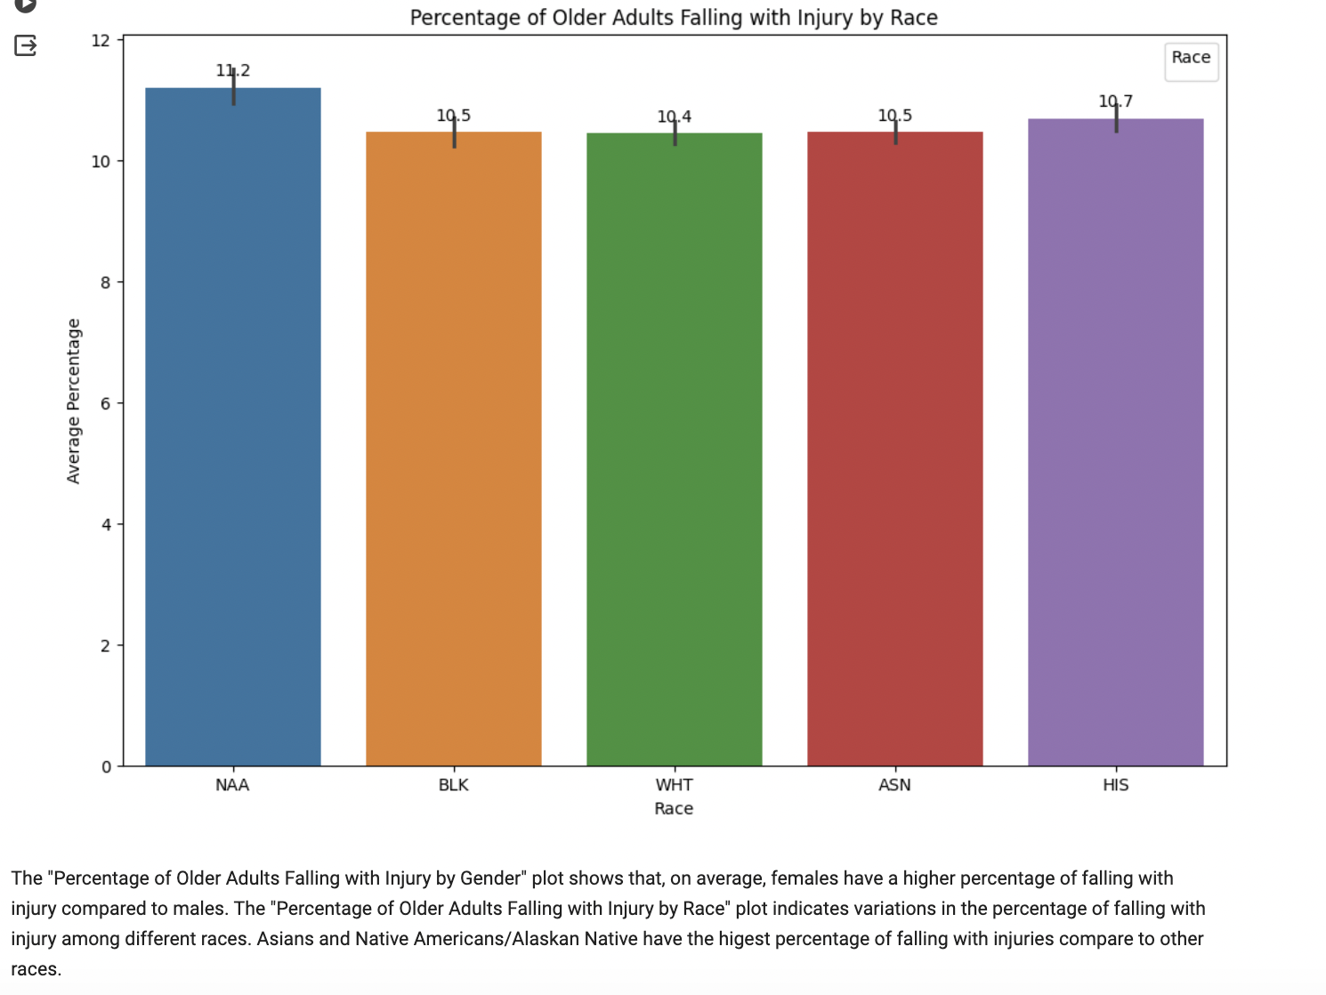

Figure 29

I'm calculating the percentage difference in fall injuries between genders and races. For genders, I compute the mean fall injury rates for males and females and then determine the percentage difference. The result shows that women have a higher probability of injuries when falling than men, with women having 49.5% higher probability of injuries than men.

Next, I perform the same calculation for races. This reveals the disparity in fall injury rates across different races, with Native Americans (NAA) having 7.2% more probability of injuries than White individuals (WHT).

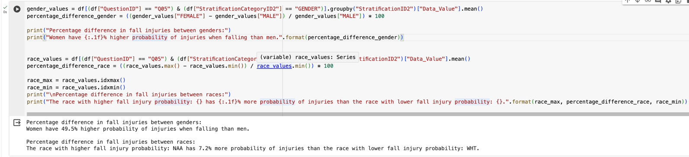

Figure 30

### Older adults with lifetime diagnosis of depression – by gender, age and race

I create a bar plot to show the percentage of older adults with depression diagnosis by gender. The bars are color-coded for female and male categories, and each bar is annotated with the corresponding percentage value. This visualization aims to illustrate the gender-based differences in depression diagnosis rates.

Based on the results, it is evident that a higher percentage of older females have a lifetime diagnosis of depression compared to males. Specifically, the percentage of females diagnosed with depression is 21.9%, while for males, it is 13.3%. WHO also highlights that an estimated 3.8% of the population experience depression, including 5.7% of adults older than 60 years, with depression being about 50% more common among women than among men. (WHO, 2023)This suggests that older females may be more susceptible to depression than males in this demographic group. These findings highlight the importance of gender-specific approaches in addressing mental health issues among older adults.

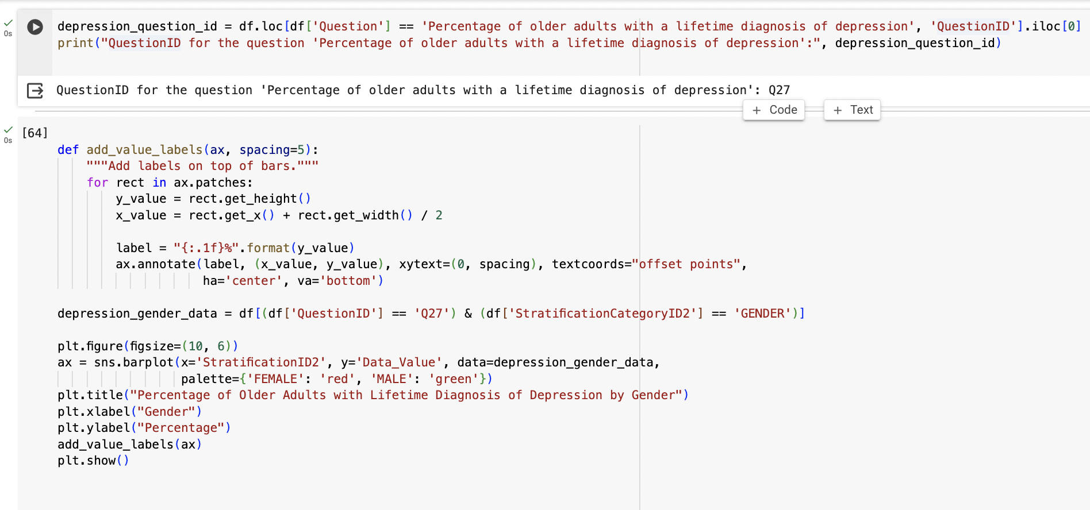

Figure 31

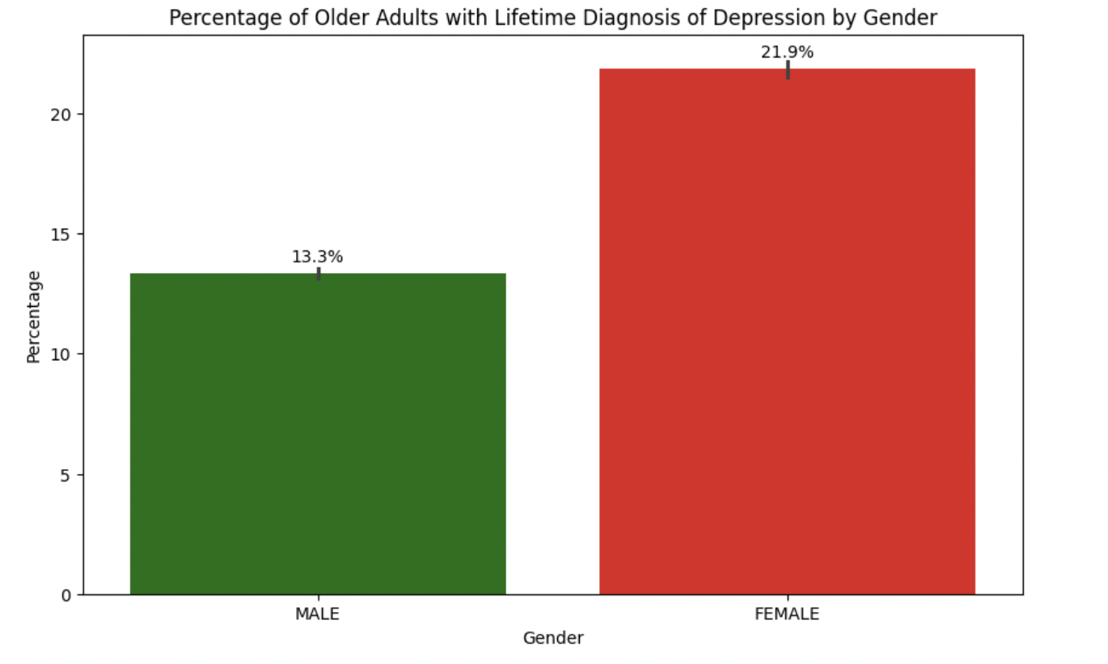

Figure 32

The analysis reveals a higher depression rate among adults aged 50-60 (19.8%) compared to those aged 65+ (16.0%). This highlights the importance of tailored interventions for the 50-60 age group and suggests a need for further research into factors influencing depression in this demographic.

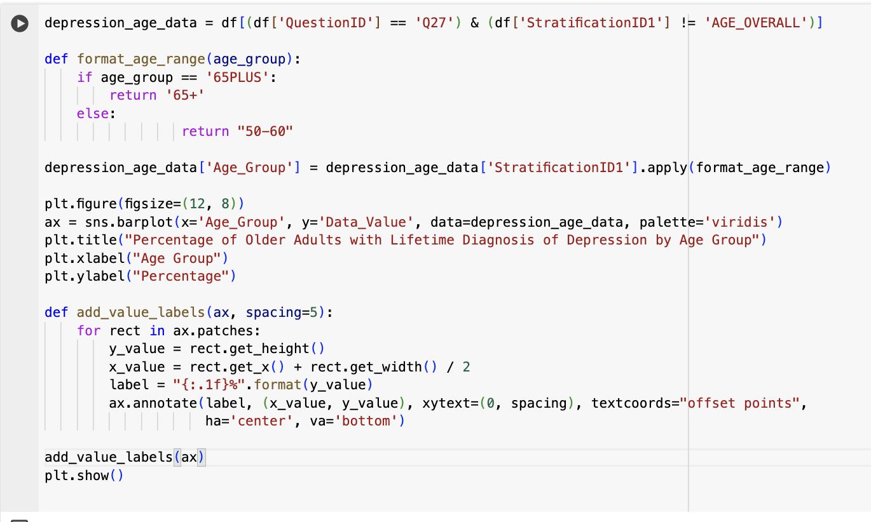

Figure 33

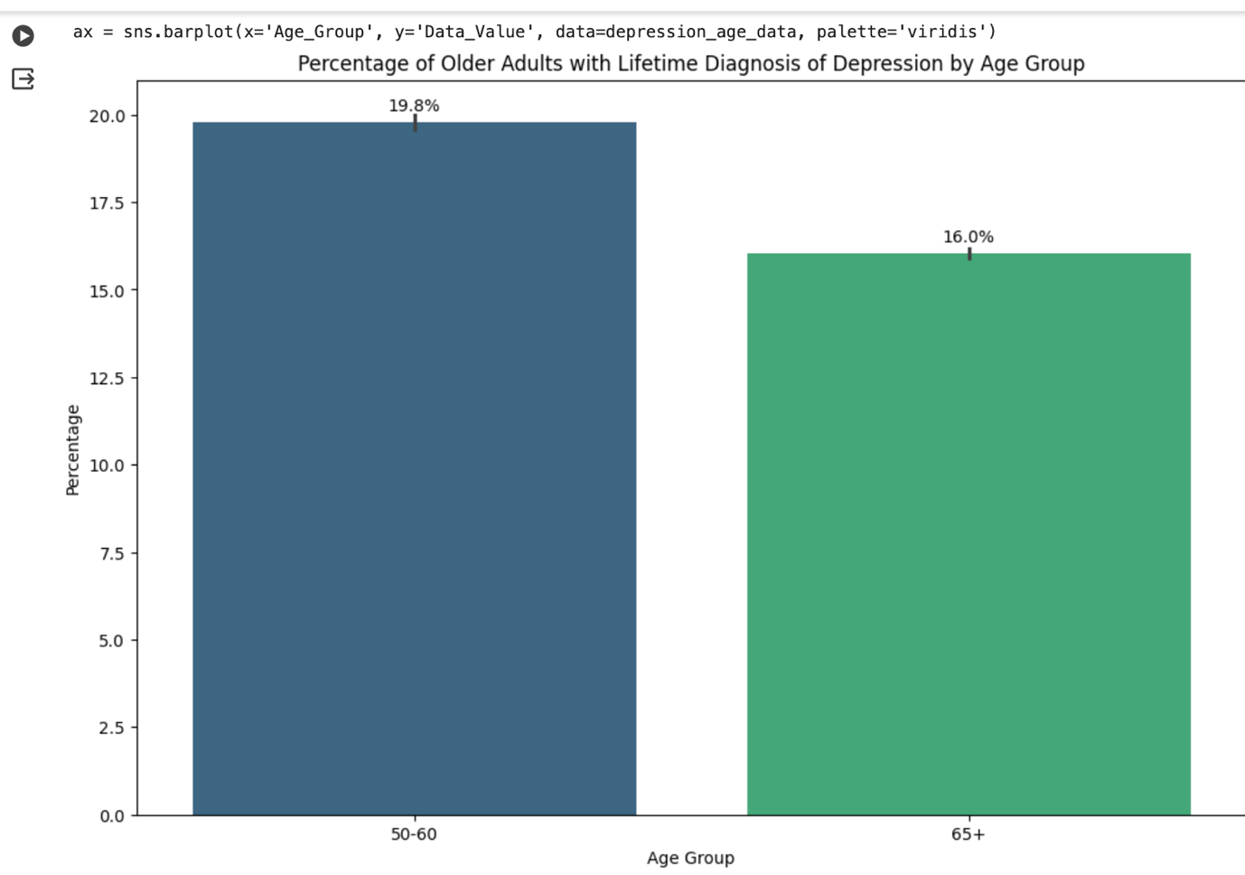

Figure 34

The analysis of depression rates among different racial groups reveals variations in prevalence. The data indicates that Native American older adults have the highest percentage of lifetime diagnosis of depression (19.3%), followed by Hispanic (18.7%) and White (18.3%) individuals. Black older adults have a relatively lower prevalence of depression (17.0%), while Asian older adults exhibit a similar rate to Black individuals (17.7%). The percentage difference between the lowest (Black: 17.0%) and highest (Native American: 19.3%) values suggests a significant 13.5% higher prevalence of depression among Native American older adults compared to Black older adults.

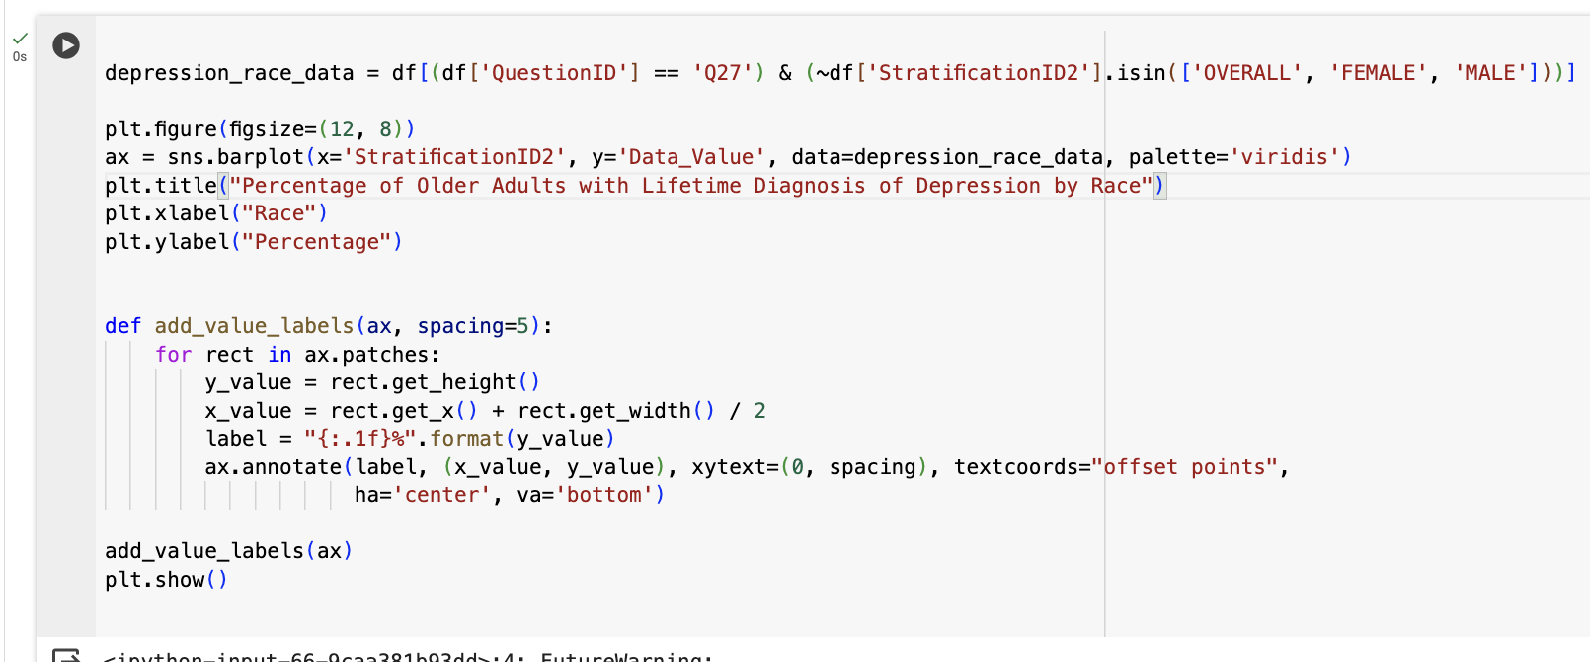

Figure 35

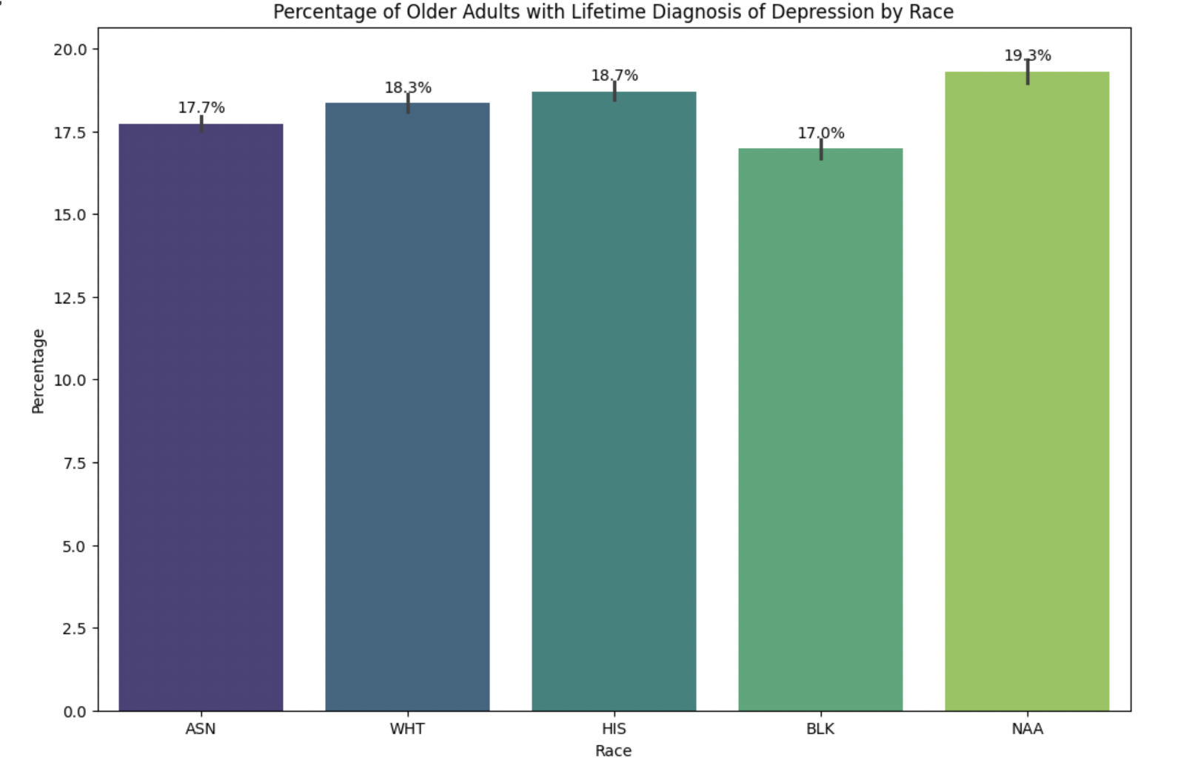

Figure 36

### Depression diagnosis trends and predictions - by gender

Analysing depression diagnosis trends by gender (Question Q27) over time involved filtering the dataset for relevant gender categories (FEMALE and MALE) and grouping the data by gender and year to calculate mean diagnosis rates. Linear regression models were fitted to historical data to predict future rates (2022-2025), and the results were plotted separately for each gender, with annotations for each data point.

Based on the analysis, it is evident that both female and male older adults are experiencing a decline in depression diagnosis rates over time. Specifically, the average rate of change indicates a decreasing trend, with females experiencing a slightly slower decline (-0.13 per year) compared to males (-0.23 per year). Additionally, the percentage change in depression diagnosis rates further confirms this downward trend, showing a decrease of 6.12% for females and a more pronounced decrease of 18.08% for males. These findings suggest positive developments in mental health outcomes among older adults, with males showing a more substantial improvement compared to females over the analysed period.

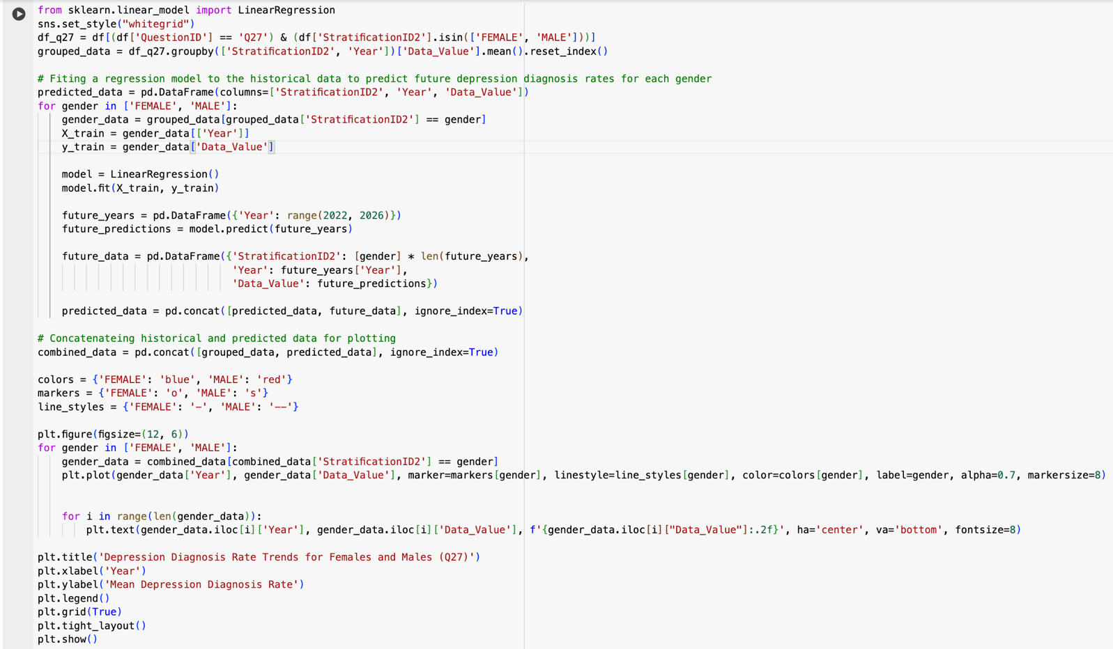

Figure 37

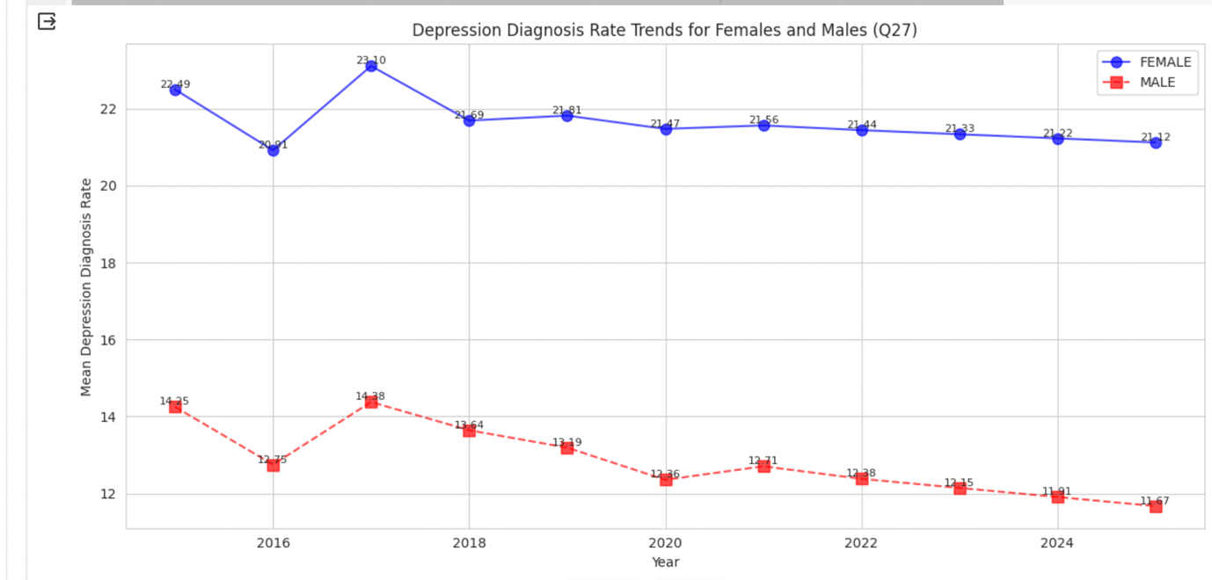

Figure 38

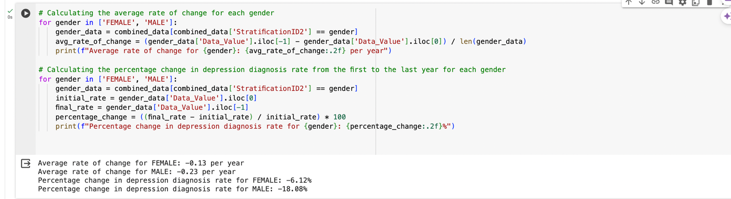

Figure 39

### Data extraction

This code extracts latitude and longitude coordinates from a 'Geolocation' column and stores them in separate 'Latitude' and 'Longitude' columns in the DataFrame. This process enables spatial analysis by breaking down the geolocation data into its constituent parts, allowing for mapping and geographical visualizations in Tableau.

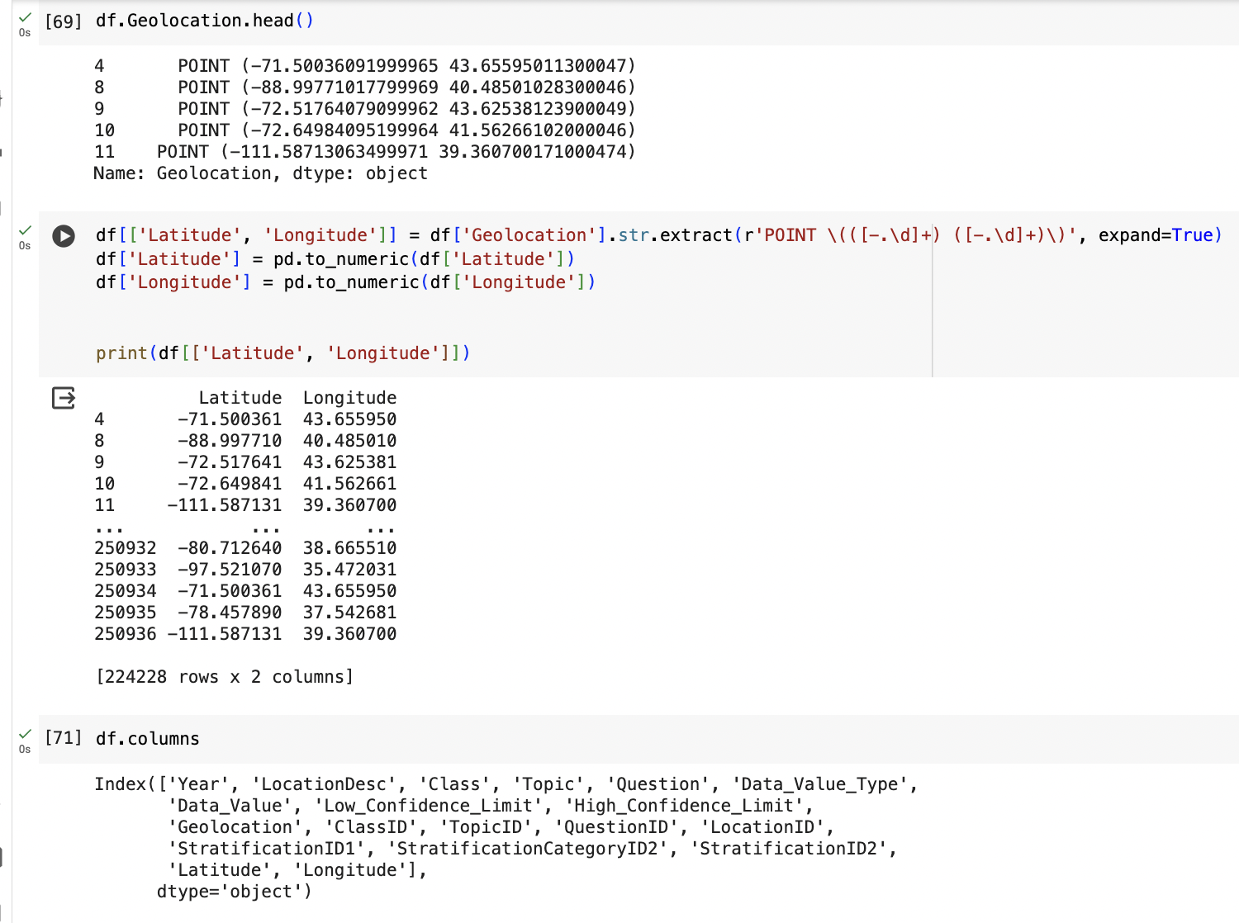

Figure 40

## Tableau analysis

[Link to my Tableau dashboard](https://public.tableau.com/views/Health_Aging_Data/Sheet1?:language=en-GB&:sid=&:display_count=n&:origin=viz_share_link)

### Trends in vegetable consumption among older adults

The analysis reveals fluctuating trends in vegetable consumption among older adults over the examined years. While both genders experienced fluctuations, females generally exhibited higher percentages compared to males across all years. Additionally, there was an overall increasing trend in vegetable consumption among both genders, with some variations observed in specific years.

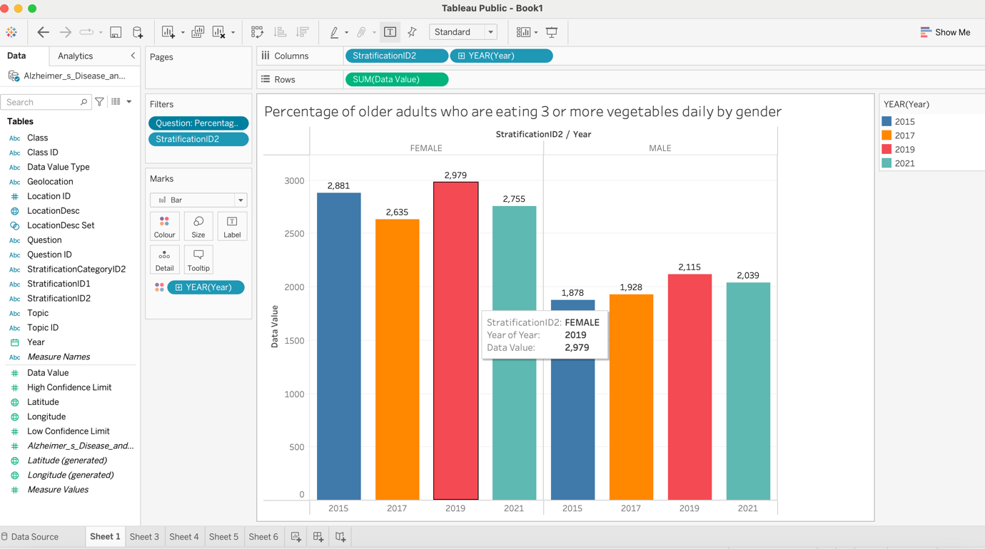

Figure 41

### Geographical analysis of binge drinking – by race

Wisconsin stands out as having the highest rates of binge drinking for both genders across all years.

The states with the lowest rates of binge drinking vary between females and males, with Oklahoma consistently among the lowest for females and Utah consistently among the lowest for males.

There is a noticeable difference in binge drinking rates between genders, with males generally exhibiting higher rates compared to females.

The percentage difference between the highest binge drinking rates for females and males varies each year but generally shows a significant disparity.

In most years, males consistently have higher binge drinking rates compared to females, with percentage differences ranging from 57.1% to 103.9%. To calculate this values I used this formula $\frac{|V1-V2|}{[\frac{\left(V1+V2\right)}{2}]} × 100= ?$

The trend suggests that binge drinking rates among males tend to be consistently higher than among females across different states and years. (Wilsnack, 2018)

Furthermore, it is important to noticed that females are more likely to experience alcohol-related health problems at lower drinking rates and are more vulnerable to the negative consequences of binge drinking compared to males. (Dir Allyson L., 2017)

This analysis highlights the need for targeted interventions and policies to address binge drinking behaviour, particularly among males, to reduce disparities and promote public health and safety.

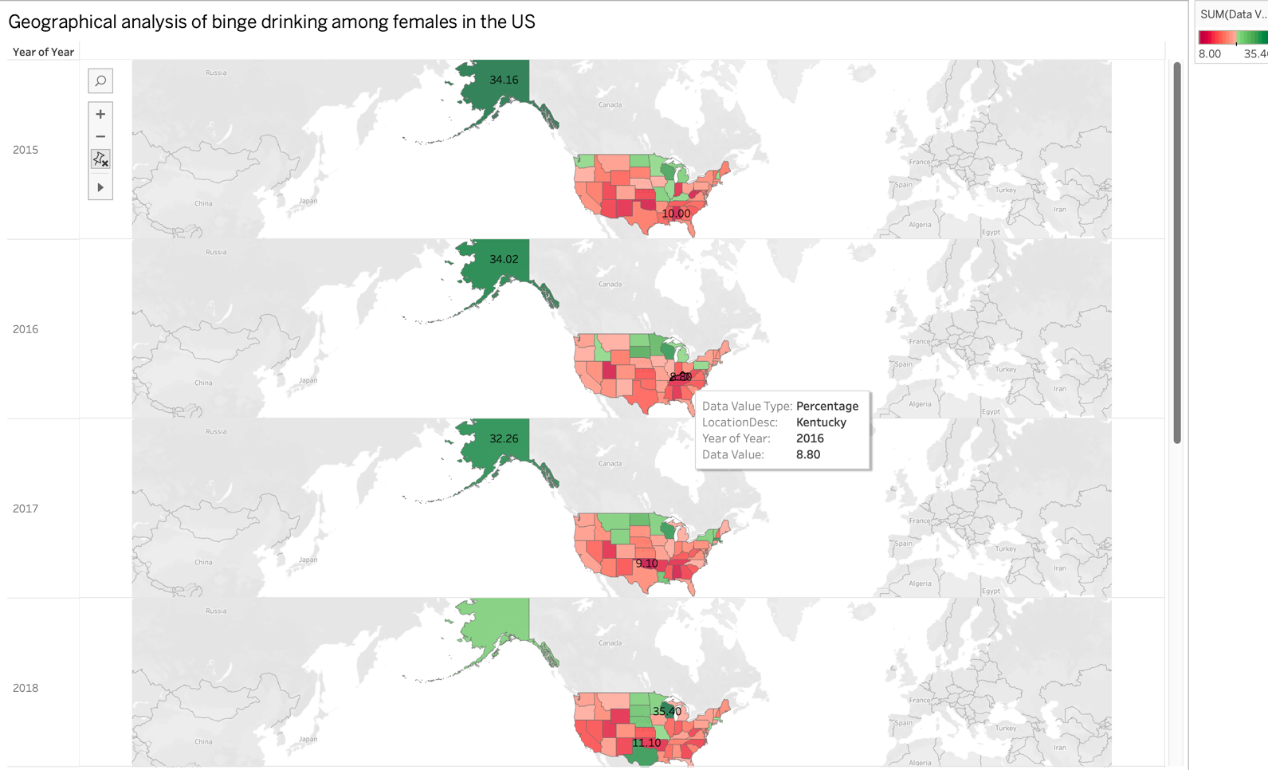

Figure 42

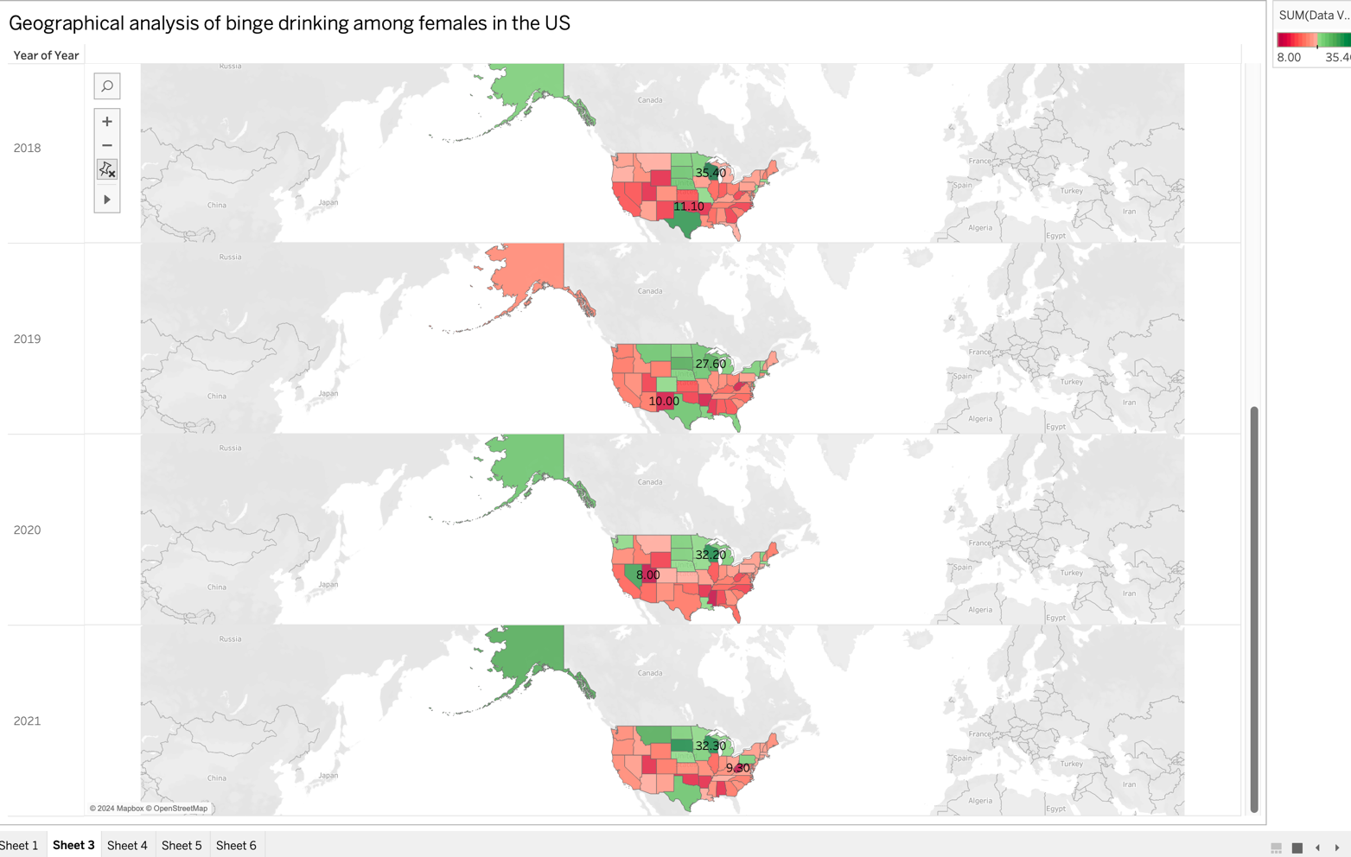

Figure 43

Figure 44

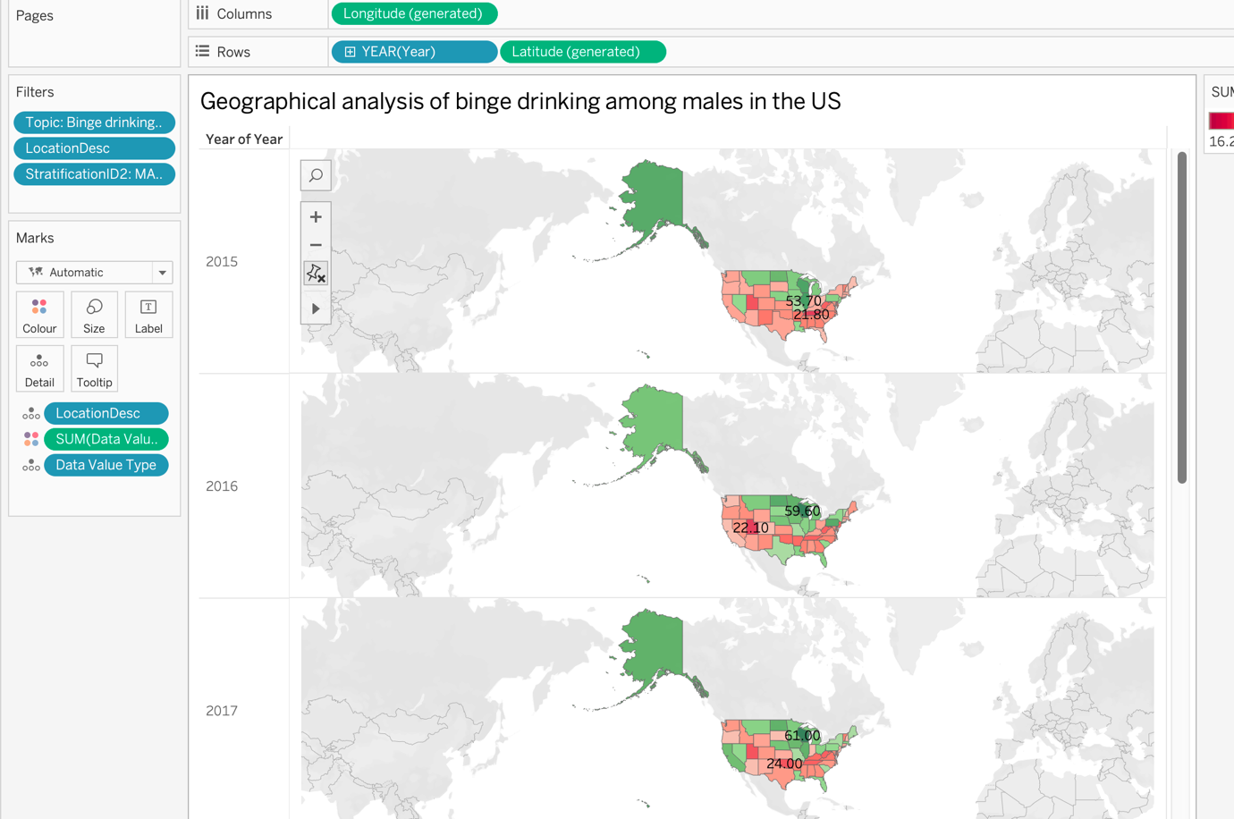

Figure 45

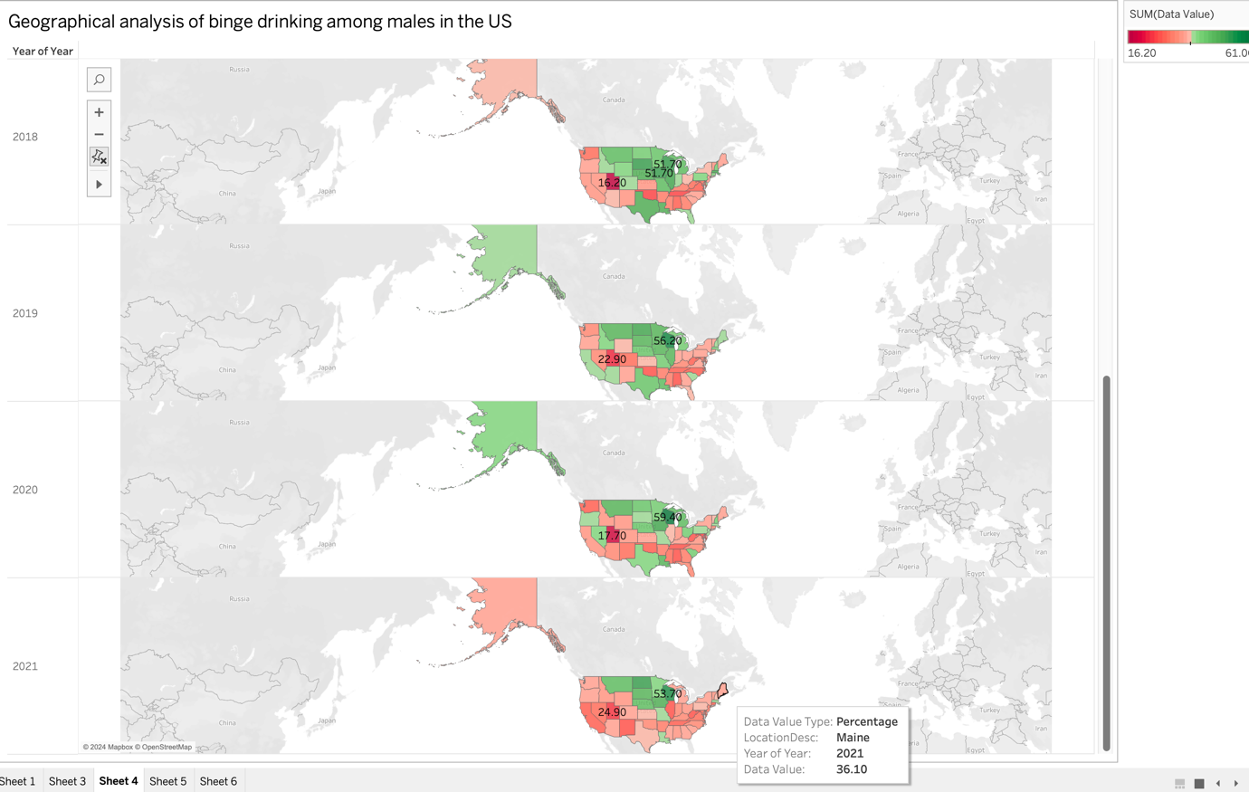

Figure 46

### Sleep analysis – by race

White older adults consistently have the highest percentage of sufficient sleep across all years. Asian older adults generally have the second-highest percentage of sufficient sleep, with values close to those of White older adults.

Black older adults consistently have the lowest percentage of sufficient sleep among the racial groups analysed, indicating a potential disparity in sleep quality and duration.

Hispanic and Native American older adults show varied percentages of sufficient sleep over the years, with fluctuations in values. According to a Yale study, Black individuals consistently report shorter sleep durations compared to White individuals, with the proportion of Black people reporting fewer than 7 hours of sleep per day increasing significantly over a 15-year period. (Caraballo-Cordovez, 7.04.2022)

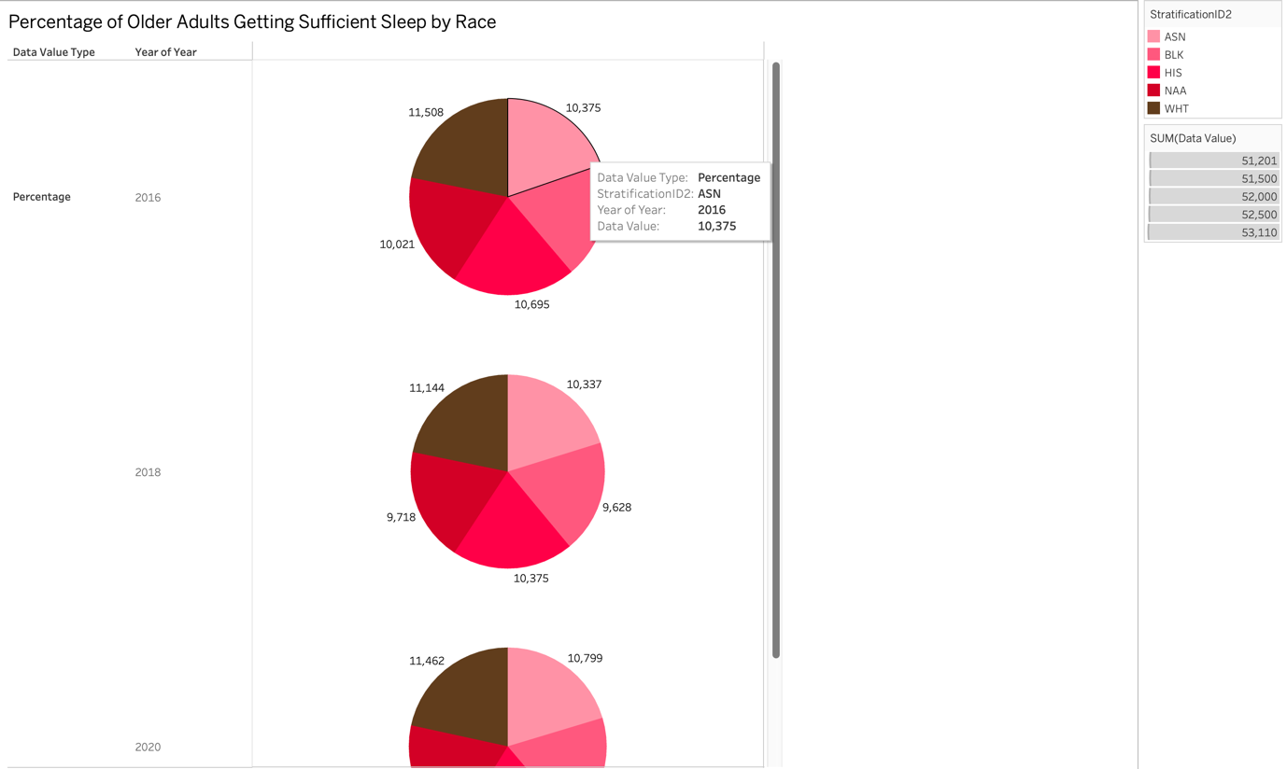

Figure 47

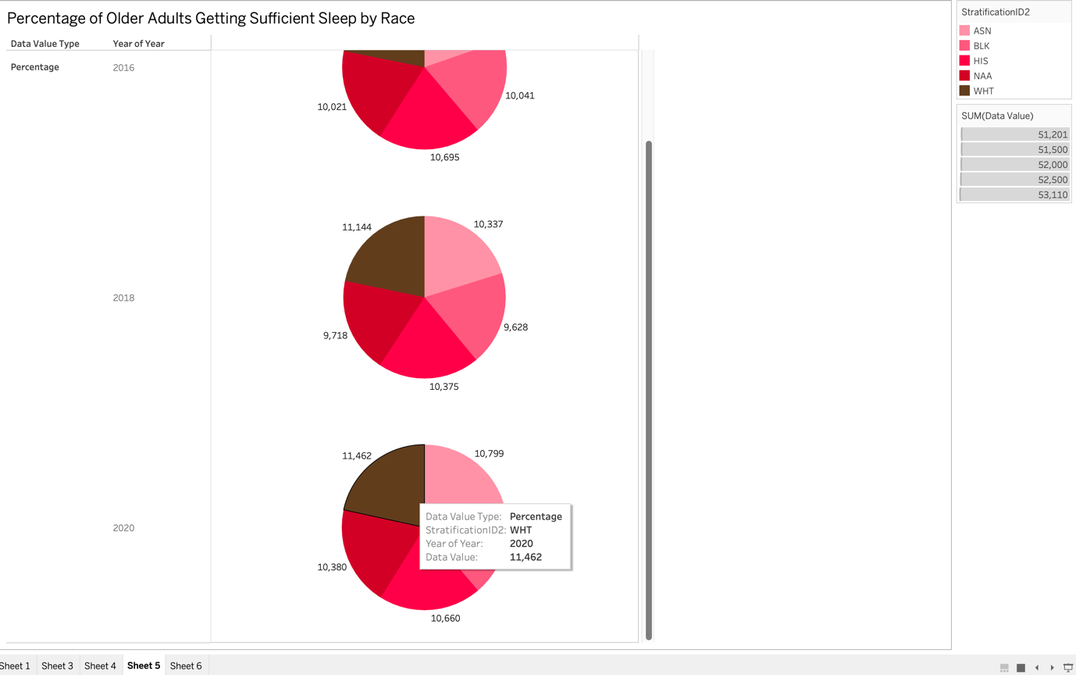

Figure 48

# Evaluation

Throughout the analysis process, a range of operations were conducted using Python and Tableau to explore and interpret various aspects of the datasets provided. These operations, including data cleaning, preprocessing, visualization, and modeling, aimed to uncover meaningful insights and patterns within the data.

Python libraries such as pandas, NumPy, and scikit-learn were utilized effectively to manage the data and perform essential tasks like imputation for handling missing values and regression analysis for trend prediction. These techniques enabled me to gain valuable insights into trends and patterns related to depression rates, binge drinking behaviour, and sleep quality among older adults.

In Tableau, visualizations were created to present findings in an intuitive and accessible manner. Through interactive dashboards, I was able to dynamically explore the data and identify trends and disparities across different demographics. This visual approach facilitated a deeper understanding of the data and its implications.

Overall, my analysis has yielded valuable insights into health-related phenomena among older adults. While there is always room for improvement, particularly in areas such as model selection and feature engineering, the analysis has provided actionable insights that can inform public health interventions and policy decisions.

## Limitations

Handling the large and complex dataset presented several challenges, including extensive missing values and cluttered data. The introduction of different approaches was prompted by a failure of analysis tools such as Weka to handle this complexity. The sheer volume of data necessitated extensive processing times and strained computational resources, resulting in considerable time investments for data preparation and analysis. To address these challenges, data pre-processing techniques were applied to manage missing values and streamline the dataset. Python libraries such as pandas and scikit-learn proved essential for efficient data manipulation and modelling, offering greater flexibility than traditional software. Another notable challenge involved the geolocation data format, which required transformation into latitude and longitude coordinates for compatibility with Tableau. This restructuring was necessary due to the original format's incompatibility with Tableau's mapping functionalities, which would have hindered geographical analysis.

# Conclusion

In conclusion, this project has been a valuable learning experience, providing insights into data analysis techniques, challenges, and best practices. Through the process of exploring and analysing diverse datasets, I have gained a deeper understanding of data manipulation, visualization, interpretation and machine learning techniques.

One of the key takeaways from this project is the importance of data pre-processing and cleaning in ensuring the reliability and accuracy of analysis results. Handling large datasets with missing values and inconsistencies required meticulous attention to detail and the implementation of effective data cleaning techniques.

Moreover, this project has highlighted the significance of leveraging advanced analytical tools such as Python and Tableau to extract meaningful insights from complex datasets.

# Bibliography

Caraballo-Cordovez, D. C. (7.04.2022). *Evaluation of Temporal Trends in Racial and Ethnic Disparities in Sleep Duration Among US Adults.* JAMA Network Open.

Dir Allyson L., B. R. (2017). Gender Differences in Risk Factors for Adolescent Binge Drinking and Implications for Intervention and Prevention. *Frontiers in Psychiatry*.

*WHO*. (2023, March 31). Retrieved February 2024, from https://www.who.int/news-room/fact-sheets/detail/depression

Wilsnack, R. W. (2018). Gender Differences in Binge Drinking. *Alcohol research : current reviews, 39,1*, 57-76.